Jeppe High School for Boys

Grade: 11
Examination: Life Orientation

Date: 23rd November 2021
Duration: 2½ Hours
Total Marks: 100
Examiner: B. Riskowitz and J. de Lange
QC Moderator: R. Riskowitz
Number of Pages: 9

Instructions:

- Complete the front cover of your answer booklet.
- Answer all of the questions in the answer booklet provided.
- Number in the middle of the page.
- Rule off after each section.
- The following are not allowed in the examination room: school bags, cell phones,
smart watches, tablets, books, dictionaries, notes, sketches or paper.
Only the official examination material distributed by the invigilator is allowed.

SECTION A (COMPULSORY)
Answer ALL of the questions in this section.
QUESTION 1
1.1 Various options are provided as possible answers to the following questions.
Choose the most correct answer and write only the letter (A-D) next to the
question numbers (1.1.1 to 1.1.5) in the ANSWER BOOK, e.g. 1.1.6 B.

1.1.1 Climate change can be combated in which of the following ways?

- Encourage people to reduce their carbon footprint by cycling to work.
- Only support larger fishing companies who use nets and fish regularly.
- Buy spray deodorant instead of roll-on as roll-on releases toxic gases.
- Plant more trees so that they can release more carbon dioxide into the air.

1.1.2 Representation can be defined as:

- when members of parliament speak or act on behalf of groups or individuals.
- allowing all citizens to personally speak to government officials.
- extremely radical views that can highlight the inequalities within S.A.
- misleading the public by displaying false information in the media.

1.1.3 When taking out a student loan:

- students only need to pay back their student loan if they find a job
- students will have to pay back the interest while they study.
- students do not need someone to apply for the loan with them.
- companies will often pay back the loan when they employ graduates.

1.1.4 Detrimental factors within a relationship that could harm an individual’s
well-being could include:

- parents violating privacy by asking permission to use their child’s phone.
- a partner violating their spouse’s rights by not paying for meals.
- children violating their parent’s trust by not doing what the parent expects.
- violating the right to freedom of expression by dictating a partner’s wardrobe.

1.1.5 Which of the following is an example of domestic violence?

- A criminal breaks into the house and violently harms the occupants.
- A mother causes physical harm to her son through severe beatings.
- A mother accidentally stands on her child’s foot, causing them pain.
- A man gets into a fight outside of a club and must be sent home.
(5X1) (5)
1.2 Give ONE word/term for each of the following descriptions. Write only the
word/term next to the question numbers (1.2.1 to 1.2.5) in the ANSWER
BOOK.

1.2.1 The painless killing of a patient suffering from an incurable and
painful disease or in an irreversible coma. (1)

1.2.2 The fact or condition of being accountable; responsibility. (1)

1.2.3 Moral principles that govern a person's behaviour or the
conducting of an activity. (1)

1.3 Answer the following questions by writing the answer next to the question
numbers (1.3.1 to 1.3.4) in the ANSWER BOOK. Write your answers in full
sentences.

1.3.1 Give TWO examples of the negative effects that climate change can
have on the oceans. (2X1) (2)

1.3.2 Explain why NBTs are important. (1X2) (2)

1.3.3 Why do Technical and Vocational Education and Training (TVET)
colleges still hold importance in South Africa. (2X1) (2)

1.3.4 Discuss the importance of CBOs (community-based organisations)
to help protect the constitutional rights of those within their
community. (1X2) (2)

1.4 Study the image below and answer the questions that follow:

Source: Time. 2020. “Every Child on Earth Faces 'Existential Threats' From Climate Change, Report Finds” Available from: https://time.com/5786395/climate-change-children-threatened/
RCLs and Climate Change
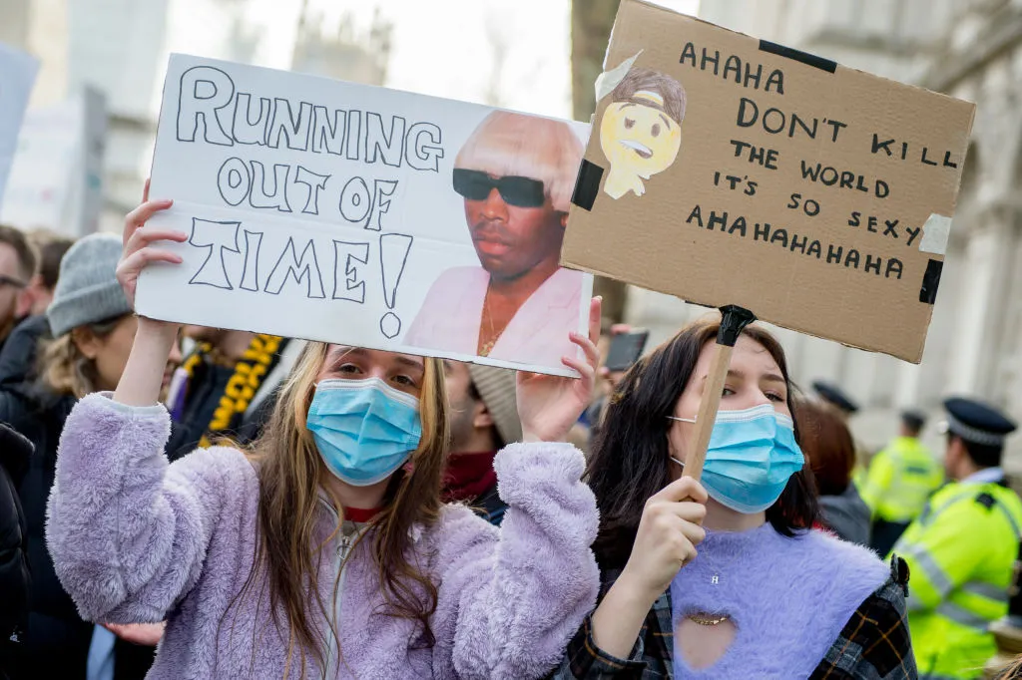

1.4.1 Explain why teenagers should take positive actions to decrease
their carbon footprint. (1X2) (2)

1.4.2 Recommend ONE possible strategy that the RCL could apply
which could encourage greater transparency between this body
and the rest of the school. (1X2) (2)
TOTAL SECTION A: 20

SECTION B (COMPULSORY)
Answer ALL of the questions in this section. Write your answers in full sentences.

QUESTION 2

Read the extract below and answer the questions that follow:

Source: Teenactiv. 2021. Available from: www.teenactiv.co.za
60% of SA teens have been drunk

Young children should be at school, learning and playing, yet reports indicate that Gauteng’s youngest drug dealer is an eight-year-old boy from Douglasdale. Studies report that 12% of all South African learners have used illegal substances, including heroin, mandrax and cocaine. Pressure from peers and unsafe attitudes are only some of the factors that contribute towards this crisis. Are they not being educated on the dangers and their own personal safety?
Furthermore, by the age of 18, more than 60% of teenagers have been drunk. Studies have also shown that children who start drinking before the age of 15 are four times likelier to become alcoholics. One can only wonder at the physical impacts that such substance abuse will have on our youth.

2.1 Give the definition of the term substance abuse. (1X2) (2)

2.2 State TWO ways in which teenagers may feel pressured by their peers
to drink alcohol or take drugs. (2X1) (2)

2.3 Explain ONE unsafe attitude towards substance abuse within a community. (1X2) (2)

2.4 Discuss TWO long-term physical impacts of substance abuse on teenagers. (2X2) (4)

2.5 Why would substance abuse continue despite the fact that teenagers are
taught against it. (2X2) (4)

2.6 Provide TWO strategies that teenagers may consider to protect themselves
from illegal substances in promotion of their personal safety. In your answer,
also indicate how this could be beneficial to teens regarding other aspects
within their lives. (2X3) (6)

[20]

QUESTION 3

Read the extract below and answer the questions that follow:

Source: Teenactiv. 2021. Available from: https://jennifergrantinternational.com
Mastering a 21st Century Interview

An interview in today’s world can present a few more elements to think about in your preparation process. Technology has had a significant impact on the recruiting and interviewing process. Today's employers are most likely going to do a little further digging than a basic background check to get to know you. In fact, 91 percent of employers check out job candidates on social media before an interview.

'Prepare well to present well' still applies for interviews and perhaps even more so in today's very competitive world. Your appearance, behaviour and communication all need to be in top form to showcase your best self.

Even though a lot of the same interview tips hold true today as they did for the past several decades, you need to be aware of what is going to give you the edge in the 21st Century.

3.1 Give the definition of the term interview. (1X2) (2)

3.2 State TWO ways in which interviews have changed because of the
advancements of the twenty first century. (2X1) (2)

3.3 Explain why the way that you dress for an interview is so important. (1X2) (2)

3.4 Discuss TWO ways how the demands of the working world have
changed with the rise of technology. (2X2) (4)

3.5 Assess TWO ways in which errors in a CV and letter of application could be
detrimental for your chances of getting the job. (2X2) (4)

3.6 Advise job seekers on how to prepare well so that they can stand out during
a twenty first century interview. In your answer, also indicate the importance
of prepping for an interview. (2X3) (6)

[20]

TOTAL SECTION B: 40

SECTION C
Answer any TWO questions in this section.
Your responses must consist of paragraphs. Marks will only be allocated for responses written in full sentences.
QUESTION 4

Study the image below and answer the question that follows:

Source: Ramirez, M. 2019. “Baby girl 05-28-19” Available from: https://michaelpramirez.com/the-abortion-debate-2019-by-michael-p-ramirez.html
Abortion
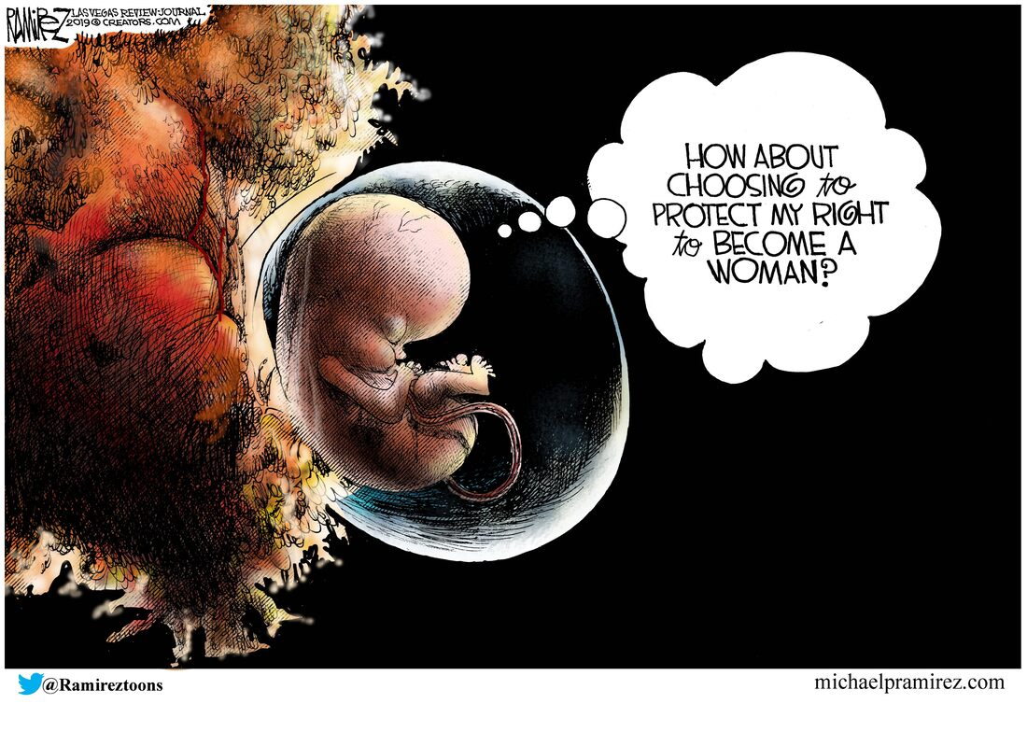

Construct an essay on Abortion.

Use the following as a guideline:

- State FOUR reasons why a woman may feel the need to have an
abortion. (4X1) (4)
- Analyse the negative effects of abortions on babies that survive abortions. (2X4) (8)
- Critically discuss the impact/importance of the psychological
consequences for a teenager who chooses to have an abortion. (2X4) (8)
[20]

QUESTION 5

Study the image below and answer the question that follows:

Source: Teenactiv. 2021 Available from: https://www.facebook.com/ISPDistrict5/photos/a.285284695158005/1383483915338072/?type=3
Risky Behaviour - Texting and Driving
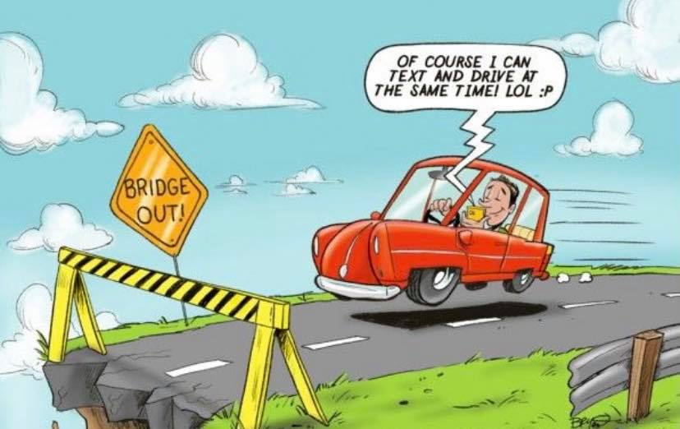

Construct an essay on Risky Behaviour - Texting and Driving.

Use the following as a guideline:

- State FOUR ways that South African drivers make use of roads in a
dangerous manner. (4X1) (4)
- Analyse why South African road users continue with unsafe driving
attitudes. (2X4) (8)
- Critically discuss the impact of the South African Roads Federation
(SARF) educating the youth on risky road usage. (2X4) (8)
[20]

QUESTION 6
Study the image below and answer the question that follows:

Source: Wilkinson, M. 2021. “3 Things You Need to Stop Lying About (On Your CV)”. Available from: https://www.coburgbanks.co.uk/blog/candidate-tips/stop-lying/
CVs and job interviews

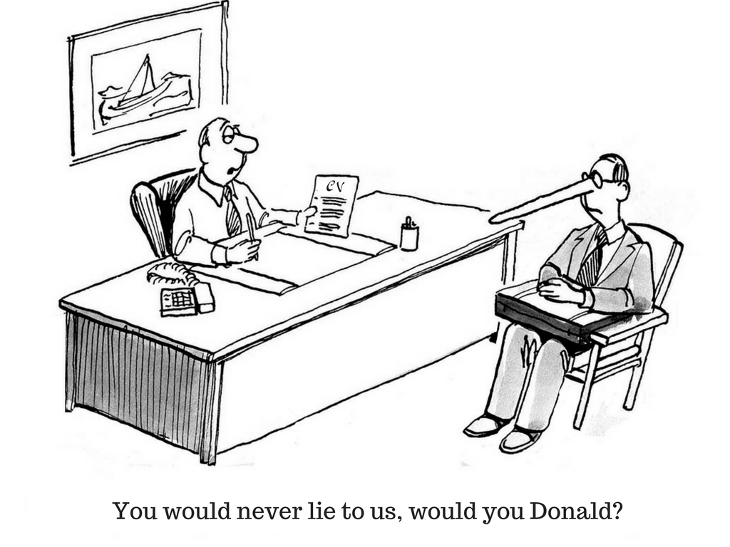
Construct an essay on CVs and Job Interviews.

Use the following as a guideline:

- State FOUR ways job seekers could make their CV stand out to potential employers. (4X1) (4)
- Analyse how errors in a CV and letter of application could be detrimental
for your chances of getting the job. (2X4) (8)
- Critically discuss the impact that lying in the job seeking process could
have on your career. (2X4) (8)
[20]

TOTAL SECTION C: 40
GRAND TOTAL: 70

