Jeppe High School for Boys

Subject: Life Orientation
Mid-Year Examination
Grade: 12

Date: 06 June 2018
Duration: 1 ½ Hours
Total Marks: 80
Examiner: B. Riskowitz
Moderators: T. Janse van Rensburg / L. Hallett
QC Moderator: C. Rattray
Number of Pages: 9
________________________________
Instructions:
- Complete the front cover of your answer booklet.
- Answer all questions in the answer booklet provided.
- Answer all questions in Sections A and B.
- Answer 2 questions from Section C.
- Write your teacher’s name on the front cover.
- Number in the middle of the page.
- Write neatly and legibly.
- Rule off after each section.
- No borrowing.
- The following are not allowed in the examination room: cell phones, school bags, ipods (or similar devices), books, dictionaries, notes, sketches or paper.
Only the official examination material distributed by the invigilator is allowed.

SECTION A: 20 Marks

QUESTION 1: Multiple Choice
Various options are provided as possible answers to the following questions. Choose the most correct answer and write only the letter (A-D) next to the question numbers 1.1 – 1.10 in the answer book. E.g. 1.6 B

1.1 A person's values refer to:
- standards of acceptable behavior, beliefs and goals.
- standards of unacceptable behaviour and beliefs.
- standards of acceptable and unacceptable behaviour and Christianity.
- standards of acceptable behaviour beliefs, goal and self-interest.

1.2 Acute stress is:
- an intense type of stress which causes 80% of illnesses.
- the stress that prevents us from locating what we need quickly.
- an intense type of stress brought on by daily challenges but passes quickly.
- relates to long-term problems and affects a person emotionally.

1.3 A responsibility of one of the national government departments is to:
- maintain public parks in the central business district of towns.
- control street trading in the central business district of cities.
- inspect workplaces to ensure that it is safe and healthy.
- monitor unauthorised use of water in particular areas.

1.4 It is the responsibility of the media to:
- not identify children who have been charged with abuse.
- promote the interests of government because the media belongs to them.
- not criticize the government of the day because it is unconstitutional.
- favour a particular political party in order to satisfy their interests.

1.5 Freedom of Expression:
- does not include incitement of violence.
- includes freedom of artistic creativity.
- does not include advocacy of hatred.
- all of the above.
[5]

QUESTION 2: Short Questions
Answer the following questions in full sentences, paying close attention to the mark allocations:

2.1 Explain the relationship between unemployment/crime and lack of self-
esteem? (2X2) (4)
2.2 Briefly explain the term “recession”. (1X2) (2)
2.3 Clarify the term “coping mechanism”. (1)
2.4 What is a “personal lifestyle plan”? (1)
2.5 Provide TWO (2) explanations for why it is important to set aims for a
campaign. (1X2) (2) [10]

QUESTION 3: Definitions
Define the following terms:
3.1 self-control (1)
3.2 educational programmes (1)
3.3 human rights violations (1)
3.4 nepotism (1)
3.5 volunteering (1) [5]
SECTION A: 20 MARKS

SECTION B: 30 Marks

QUESTION 4: Case Study
Read the case study below and answer the questions that follow:
Source: Africa Metro. 2015. http://www.africametro.com/headline/xenophobia-the-brutal-death-of-emmanuel-sithole/
Shortly before 7am yesterday, Sunday Times journalists were in Alexandra township, near Sandton, speaking to shop owners who had their businesses looted overnight. Then this happened…

In a gutter in Alexandra a Mozambican man [Emmanuel Sithole] stopped and lay down. The gash to his chest meant he could go no further.
It began on Friday night when mobs blockaded Arkwright Avenue, one of the main thoroughfares in Alexandra, with rubble and burning tyres. Foreign-owned shops’ roofs were ripped open and metal gates torn away as looters went on the rampage. Outside one spaza shop, a man in a black corduroy jacket and red shirt was walking along the road. Suddenly a young man dressed in a grey tracksuit jacket beat him over the head with a wrench. The man in the red shirt tried to fend off the blows, his arms raised. “Are we safe here?” asked a South African woman watching the attack.

Again, the man in the red shirt raised his hands, pleading for mercy. But his pleas were in vain. He was stabbed … repeatedly.

4.1 Define “xenophobia” and quote a sentence from the scenario showing why
people, like Emmanuel, were attacked. (2)
4.2 Critically analyse what would cause a person to treat another human being
with such violence (in the context of the above case study). (2X2) (4)
4.3 Produce an action plan which clearly shows which of Emmanuel’s human
rights have been violated, as well as the names of two institutions he can
approach to get aid. (2X2) (4)
[10]

QUESTION 5: Cartoon Analysis
Analyse the cartoon below by answering the questions that follow:
Source: Brandan. 2017. https://www.zanews.co.za/cartoons/2017/01/16/feesmustfall2017
#FeesMustFall CAMPAIGN BACK
What started and continues to be a protest about fees is fast becoming a protest about the broader consequences of inequalities where the educational resources of the country are not accessible to the poor majority.
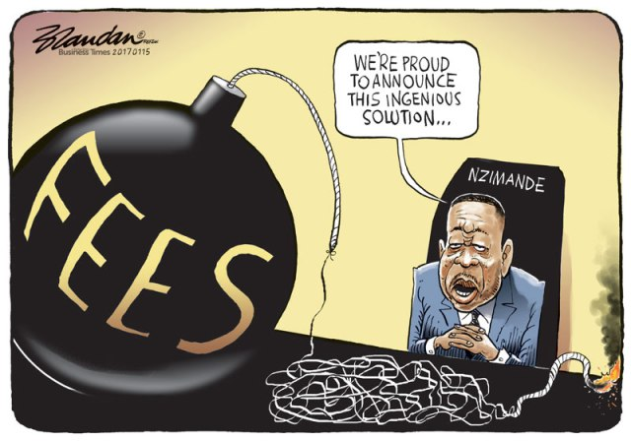

5.1 Determine what human right the #FeesMustFall campaign focuses on. (1)
5.2 Deduce why the cartoonist has depicted “fees” as a bomb with a lit fuse. (2X2) (4)
5.3 Predict what possible effects the #FeesMustFall campaign may have on
the government going into the future. (1X2) (2)
5.4 Contrast the failures and successes of this campaign. (2+2) (4)
[11]

QUESTION 6: Slide Analysis
Read the slide below and answer the questions that follow:
Source: Solove. 2007. http://slideplayer.com/slide/5146202/
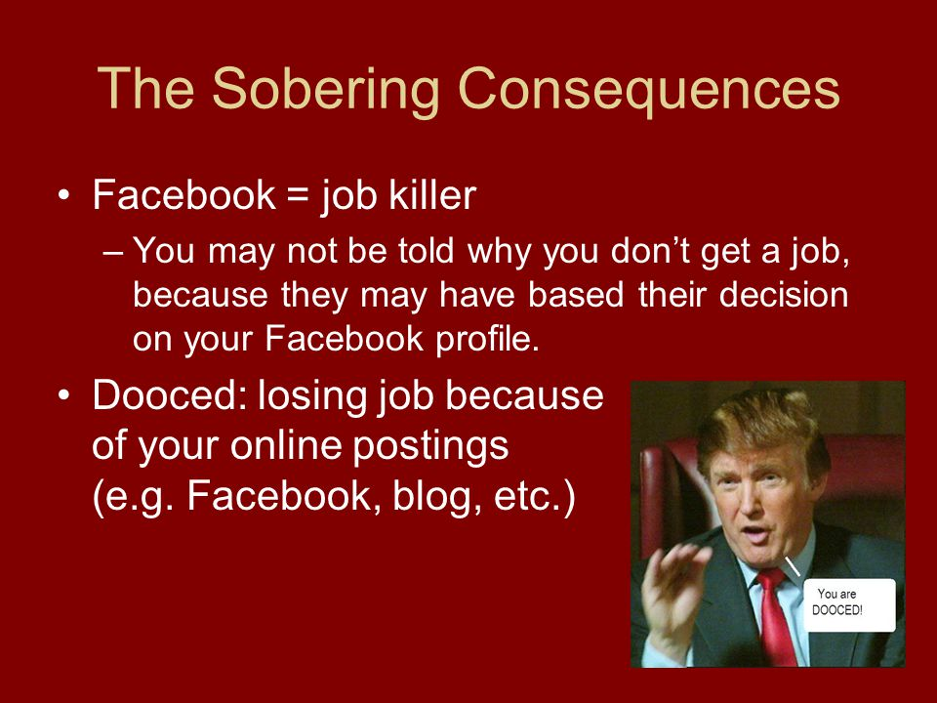

6.1 Distinguish why there would be a need to add the new word “dooced” to
the Urban Dictionary. (1)
6.2 Articulate why Facebook can be considered a “job killer”. (2X2) (4)
6.3 Determine how social media can assist someone in getting a job. (2X2) (4) [9]

SECTION B: 30 MARKS

SECTION C: 30 Marks
Only answer TWO (2) of the THREE (3) following questions. Please read all instructions as these can affect your marks to some extent.

QUESTION 7
Study the excerpt below and answer the question that follows:
Source: skillsyouneed.com. 2018. https://www.skillsyouneed.com/ips/improving-communication.html
Effective communication skills are fundamental to success in many aspects of life. Many jobs require strong communication skills and people with good communication skills usually enjoy better interpersonal relationships with friends and family.
Effective communication is a key interpersonal skill and learning how we can improve our communication has many benefits.

Construct an essay in which you:
7.1 Define “personality” and name TWO (2) types of personality.
7.2 Discuss THREE (3) ways in which these personality types can affect effective
communication.
7.3 Evaluate the extent to which the following factors can influence effective
communication:
a) acceptance of responsibility
b) appropriate expression of views and feelings
c) attitudes and values.
[15]
AND/OR

QUESTION 8
Study the sources below and answer the question that follows:
Source: Deford. 2000. https://www.amazon.com/Sports-Illustrated-Magazine-Kournikova-Deford/dp/B002XUXIC2 and Wade, 2011, https://thesocietypages.org/socimages/2011/01/14/portraying-athletes-his-and-hers-sports-illustrated-covers/
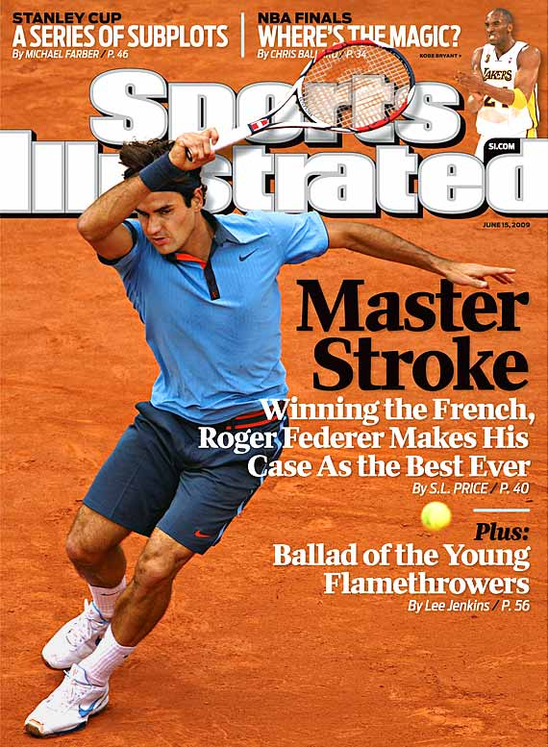
TENNIS STARS ‘ILLUSTRATED’
WORLDVIEWS – MALE VS FEMALE GENDER

Compose an essay that addresses the following:
8.1 Define the following terms:
a) world views
b) gender
8.2 Give an analysis of how the media has chosen to depict these two sports
personalities on the magazine covers.
8.3 Debate how media coverage of sports personalities in this case portrays gender
roles in sports.
[15]
AND/OR

QUESTION 9
Analyse the cartoon below and answer the question that follows:
Source: ABC. 2014. http://www.abc.net.au/news/2014-10-21/gough-whitlam-remembered-as-giant-of-australian-politics/5828836
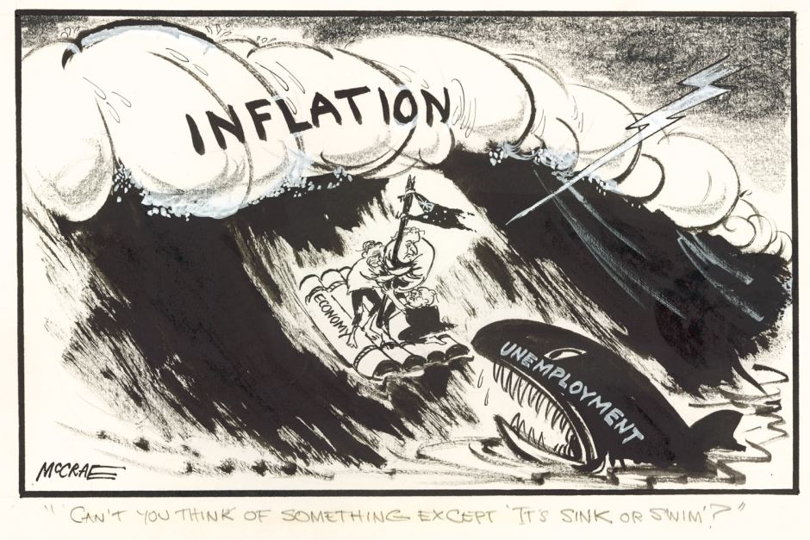

Compile a magazine article which considers and answers the following:
9.1 Report on THREE (3) reasons why South Africa has such a high unemployment
rate?
9.2 What impact does the high youth unemployment rate have on the following:
a) economy
b) infrastructure
c) health care.
9.3 Suggest THREE (3) strategies in which the youth can ensure that they do not
become part of the unemployment statistics.
[15]

SECTION C: 30 MARKS
End of Paper
TOTAL: 80 MARKS

