Jeppe High School for Boys

Grade: 8
Examination: Life Orientation

Date: 23rd November 2021
Duration: 1½ Hours
Total Marks: 70
Examiner: B. Riskowitz and J. de Lange
QC Moderator: R. Riskowitz
Number of Pages: 7

Instructions:

- Complete the front cover of your answer booklet.
- Answer all of the questions in the answer booklet provided.
- Number in the middle of the page.
- Rule off after each section.
- The following are not allowed in the examination room: school bags, cell phones,
smart watches, tablets, books, dictionaries, notes, sketches or paper.
Only the official examination material distributed by the invigilator is allowed.

SECTION A (COMPULSORY)
Answer ALL of the questions in this section.
QUESTION 1
1.1 Various options are provided as possible answers to the following questions.
Choose the most correct answer and write only the letter (A-D) next to the
question numbers (1.1.1 to 1.1.5) in the ANSWER BOOK, e.g. 1.1.6 B.

1.1.1 Which of the following would be an ideal way for a visual learner to learn?

- Drawing charts and diagrams.
- Singing rhymes and chants.
- Doing and enjoying touching.
- Reading their class notes.

1.1.2 What is meant by the term ‘refusal’?

- Saying yes.
- Saying no.
- Not saying no.
- Not making a choice.

1.1.3 Substance abuse refers to:

- Continued use of tobacco or alcohol and illegal drugs.
- Continued use of legal substances that make you feel good.
- Being dependant on something or someone that abuses you.
- Being dependant on a substance that makes you feel good.

1.1.4 Appropriate behaviour to stop and avoid substance abuse:

- Take up hobbies and sport to find friends that are users.
- Take only once a week to make you feel good about yourself.
- Do volunteer work, it makes you feel good about yourself.
- Play sports where substances are available to you.

1.1.5 Rehabilitation options include:

- Hospitals, non-governmental organisations and counselling.
- Non-governmental organisations, counselling and after care.
- Hospitals, counselling and places of substance abuse.
- Non-governmental organisations, counselling and the national drug line.

(5X1) (5)

1.2 Give ONE word/term for each of the following descriptions. Write only the
word/term next to the question numbers (1.2.1 to 1.2.5) in the ANSWER
BOOK.

1.2.1 The idea one has of one's abilities, appearance, and personality. (1)

1.2.2 A ceremony or event marking an important stage in someone's life,
especially birth, the transition from childhood to adulthood, marriage,
and death. (1)

1.2.3 A mark of disgrace associated with a particular circumstance,
quality, or person. (1)

1.2.4 The collection and storage of rain, rather than allowing it to run off. (1)

1.2.5 A formal written request, typically one signed by many people,
appealing to authority in respect of a particular cause. (1)
TOTAL SECTION A: 10

SECTION B (COMPULSORY)
Answer ALL of the questions in this section. Write your answers in full sentences.
QUESTION 2

Read the extract below and answer the questions that follow:

Source: https://www.avert.org/living-with-hiv/stories/lara Available from: Teenactive
HIV/AIDS
I was diagnosed with HIV when I went for my antenatal check. I guess I didn’t know how I felt about it at first, but as time passed I took responsibility. It was hard to start my meds. I felt humiliated and scared of rejection… I ended up not taking them first-time around.
I learnt that HIV has no power over me and my identity! So I started managing my illness better and now I'm studying HIV/AIDS management and counselling at college.

2.1 Give the definition of the term HIV/AIDS. (1X2) (2)

2.2 Identify TWO ways that Petunia may have become infected with HIV. (2X1) (2)

2.3 Explain ONE of the ways that stigmatisation impacted the woman in the
extract emotionally. (1X2) (2)

2.4 Differentiate between HIV and AIDS. (2X2) (4)

2.5 Assess TWO ways that the woman can manage and fight her illness
to help her stay healthy for longer. (2X2) (4)

2.6 Recommend TWO ways that Grade Eight learners can demonstrate
care for someone living with HIV/AIDS? In your answer, also indicate
how this will allow these learners living with HIV/AIDS make better decisions
in managing their illness. (2X3) (6)
[20]

TOTAL SECTION B: 20

SECTION C
Answer any TWO questions in this section.
Your responses must consist of paragraphs. Marks will only be allocated for responses written in full sentences.
QUESTION 3

Read the extract below and answer the question that follows:

Source: Green Peace, 2021. Available from: https://www.greenpeace.org/africa/en/blogs/12868/combatting-gender-based-violence-during-covid-19/
COVID-19 and Gender-Based Violence

The impact of COVID-19 on gender based violence has become a second pandemic. The government GBV and femicide command centre recorded more than 120,000 victims in the first three weeks of the initial five week lockdown, and by the middle of April 2020, the call centre in Tshwane was receiving between 500 and 1,000 calls a day. Vodacom’s support call centres saw a 65% increase in calls from women and children confined to their homes during lockdown and in need of urgent help.

Construct an essay on COVID-19 and Gender-Based Violence.

Use the following as a guideline:

- State FOUR ways that victims of gender based violence experiences are
harmed. (4X1) (4)
- Analyse why South Africa still struggles with issues of gender-based
violence despite having human rights that oppose the problem. (2X4) (8)
- Critically discuss the importance of men and boys standing up against
gender-based violence. (2X4) (8)
[20]

QUESTION 4

Study the image below and answer the question that follows:

Source: Career Guide. 2021. “5 Misconceptions Of Career Counselling To Be Aware Of”. Available from: https://www.careerguide.com/career/career-counsellors/5-misconceptions-of-career-counselling-to-be-aware-of
Career Counseling

Construct an essay on Careers and Subject Choices.

Use the following as a guideline:

- State FOUR personal aspects that you should consider when deciding on a
career. (4X1) (4)
- Analyse how the relationship between the knowledge of various school
subjects and potential careers works. (2X4) (8)
- Critically discuss the importance of Grade 9s making the best possible
subject choices going into Grade 10. (2X4) (8)
[20]

QUESTION 5

Study the image below and answer the question that follows:

Source: Unknown. 2020. “Survey: Nurses fear going to work due to lack of protection from virus”. Available from: https://www.myamericannurse.com/survey-nurses-fear-going-to-work-due-to-lack-of-protection-from-virus/
Covid-19
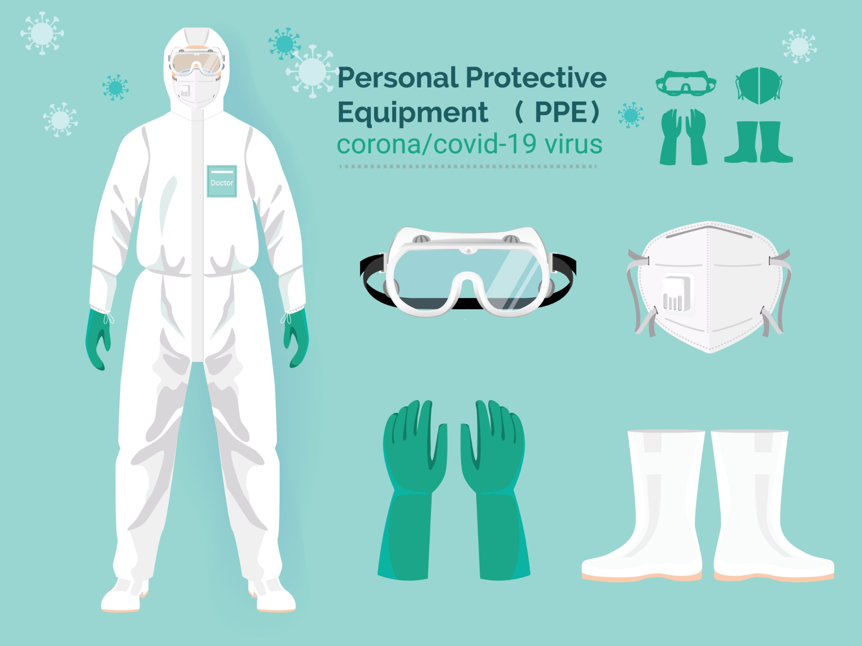

Construct an essay on Dealing with Covid-19.

Use the following as a guideline:

- State FOUR ways to protect yourself against Covid-19. (4X1) (4)
- Analyse how you can support someone who has lost someone from
Covid-19. (2X4) (8)
- Critically discuss the importance of making informed decisions about
your safety during the COVID-19 pandemic. (2X4) (8)
[20]

TOTAL SECTION C: 40
GRAND TOTAL: 70

