Jeppe High School for Boys

Grade: 9
Examination: Life Orientation

Date: 17th November 2021
Duration: 1½ Hours
Total Marks: 70
Examiner: B. Riskowitz and J. de Lange
QC Moderator: R. Riskowitz
Number of Pages: 7

Instructions:

- Complete the front cover of your answer booklet.
- Answer all of the questions in the answer booklet provided.
- Number in the middle of the page.
- Rule off after each section.
- The following are not allowed in the examination room: school bags, cell phones,
smart watches, tablets, books, dictionaries, notes, sketches or paper.
Only the official examination material distributed by the invigilator is allowed.

SECTION A (COMPULSORY)
Answer ALL of the questions in this section.
QUESTION 1
1.1 Various options are provided as possible answers to the following questions.
Choose the most correct answer and write only the letter (A-D) next to the
question numbers (1.1.1 to 1.1.5) in the ANSWER BOOKLET, e.g. 1.1.6 B.

1.1.1 Being assertive means:

- knowing your rights, so that you will fight for them without being rude.
- making demands and accepting only your way as the right way.
- not asking for help and considering only what you want and need.
- never backing down and not listening to what others think or say.

1.1.2 Prejudice is not a way to uphold the values of the constitution because:

- prejudice is an assumption not based on fact.
- prejudice can lead to greater understanding.
- prejudice includes assumptions based on truth.
- prejudice is factual knowledge about a group.

1.1.3 This act regulates the right of employees to strike and join trade unions in
South Africa:

- the Bill of Rights.
- Employee Equity Act.
- Labour Relations Act.
- Trade Unions Act.

1.1.4 A Grade 9 learner is in the final year of their:

- General Education and Training phase.
- Further Education and Training phase.
- Higher Education and Training phase.
- only B and C are correct.

1.1.5 The following is an example of a career that one could take after following
the NCV route:

- teacher.
- doctor.
- hairdresser.
- architect.
(5X1) (5)

1.2 Give ONE word/term for each of the following descriptions. Write only the
word/term next to the question numbers (1.2.1 to 1.2.5) in the ANSWER
BOOKLET.

1.2.1 Skills that are in demand by employers – usually because there
are not enough qualified professionals in that specific field. (1)

1.2.2 People of this career type prefer to work with things rather than
ideas or people. They enjoy physical activity and often like being
outdoors and working with plants and animals. (1)

1.2.3 A method of paying the income tax liability in advance, to ensure
that the taxpayer does not remain with a large tax debt on
assessment. (1)

1.2.4 Describes your convictions, what you stand for, and how you plan
to create a life that embodies your values. In other words, it
becomes your personal definition of success – one that is separate
from the approval of others. (1)

1.2.5 A formal written request, typically one signed by many people,
appealing to authority in respect of a particular cause. (1)
TOTAL SECTION A: 10

SECTION B (COMPULSORY)
Answer ALL of the questions in this section. Write your answers in full sentences.

QUESTION 2

Read the extract below and answer the questions that follow:

Source: Harding, A. 2021. Available from: https://www.bbc.com/news/world-africa-57996373

South Africa riots: The inside story of Durban's week of anarchy (29th July)

It is two weeks after South Africa was gripped by a frenzy of looting - the worst scenes of violence since the advent of democracy in 1994. But soldiers continue to patrol tense neighborhoods devastated by a week of anarchy that left more than 300 people dead.

"Everything is gone. I have no insurance. I'm worried about the future of South Africa. I'm worried about the future of my kids," said entrepreneur Dawn Shabalala, whose four small shops were looted - down to the last water pipe and electrical fitting. I fear it can happen again. But where do I go? What should I do?" she said, standing in her ransacked hair salon on a street where every shop appeared to have been cleared out, with several set on fire as well.

2.1 Identify the types of violence that people experienced during these riots? (1X2) (2)

2.2 State TWO emotional impacts of violence on an individual. (2X1) (2)

2.3 Explain ONE way in which the South African police services can be
better equipped to deal with such an instance in a better fashion. (1X2) (2)

2.4 Discuss TWO possible reasons for the high levels of violent crime
in South Africa. (2X2) (4)

2.5 Recommend TWO practical ways that schools can become involved in
promoting a culture of safety and non-violence. (2X2) (4)

2.6 Provide a strategy that the government can implement so that the community
can protect itself from such violence in the future. In your answer, also
indicate how this would increase the community spirit. (2X3) (6)

TOTAL SECTION B: 20
SECTION C
Answer any TWO questions in this section.
Your responses must consist of paragraphs. Marks will only be allocated for responses written in full sentences.
QUESTION 3

Read the extract below and answer the question that follows:

Source: SSS. 2018. “Volunteer Activity Survey”. Available from: http://www.statssa.gov.za/publications/P02113/P021132018.pdf
Volunteer Activity Survey

The 2018 volunteer survey in South Africa found that out of a population of 41 million people aged 15 years and older, 6,7% were engaged in volunteer activities in 2018. On average, 233 hours were volunteered in 2018, which is a decline of 44 hours from the 2014 figure of 277 hours.

Construct an essay on volunteering in South Africa.

Use the following as a guideline:

- State FOUR benefits of volunteerism for the community. (4X1) (4)
- Analyse the positive effects on the future careers of the 6.7% of the
population who volunteered. (2X4) (8)
- Critically discuss the impact on the communities of schools promoting the
spirit of ubuntu. (2X4) (8)
[20]

QUESTION 4

Study the image below and answer the question that follows:

Source: De Boer, C. 2015. “How To Stop Being A Slave To Your Emotions”. Available from: https://tinybuddha.com/blog/how-to-stop-being-a-slave-to-your-emotions/
How To Stop Being A Slave To Your Emotions

“I don’t want to be at the mercy of my emotions. I want to use them, to enjoy them, and to dominate them.” ~ Oscar Wilde

Construct an essay on dealing with emotions that come from grief, depression and trauma.

Use the following as a guideline:

- State FOUR ways that embracing your emotions can assist you in
developing into the best person that you can be. (4X1) (4)
- Analyse why having a support system is so important in dealing with
trauma such as the loss of loved ones from Covid. (2X4) (8)
- Critically discuss the importance of remaining positive when going
through a difficult time. (2X4) (8)
[20]

QUESTION 5

Study the slide below and answer the question that follows:

Source: Deven, D. 2014. “Goal Setting”. Available from: https://www.slideserve.com/dior/goal-setting
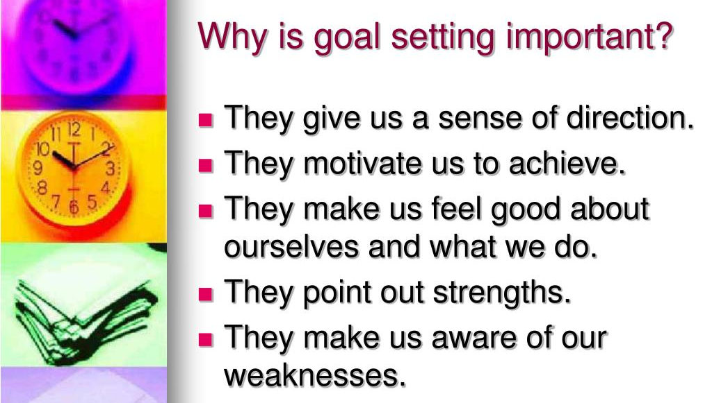

Construct an essay on goal setting and decision making as it pertains to careers.

Use the following as a guideline:

- State FOUR benefits of setting SMART goals in regards to choosing
Grade 10 subjects. (4X1) (4)
- Analyse the positive effect of choosing your subjects wisely for your future
career choices. (2X4) (8)
- Critically discuss the importance of the decision-making process when it
comes to subject choice. (2X4) (8)
[20]

TOTAL SECTION C: 40
GRAND TOTAL: 70

