MEMORANDUM

Jeppe High School for Boys

Grade: 9
Examination: Life Orientation

Date: June 2022
Duration: 1½ Hours
Total Marks: 70
Examiner: G Koopman.
QC Moderator: B. Riskowitz and R. Riskowitz
Number of Pages: 7

Instructions:

- Complete the front cover of your answer booklet.
- Answer all of the questions in the answer booklet provided.
- Number in the middle of the page.
- Rule off after each section.
- The following are not allowed in the examination room: school bags, cell phones,
smart watches, tablets, books, dictionaries, notes, sketches or paper.
Only the official examination material distributed by the invigilator is allowed.

SECTION A (COMPULSORY)
Answer ALL of the questions in this section.
QUESTION 1
1.1 Various options are provided as possible answers to the following questions.
Choose the most correct answer and write only the letter (A-D) next to the
question numbers (1.1.1 to 1.1.5) in the ANSWER BOOKLET, e.g. 1.1.6 D.

1.1.1 The “A” in SMART goals stand for:

- Amazing
- Accurate
- Achievable ✔
- Accurate.

1.1.2 NSC stands for:

- Nationals Senior Certificate
- National Senior Certificate✔
- Nations Senior Certificate
- Named Senior Certificate.

1.1.3 The term used to describe the act of delaying or postponing work:

- Time management
- Lazy
- Studying
- Procrastination.✔

1.1.4 Which of the following is an example of bad time management?

- Being on time.
- Meeting deadlines.
- Using a diary.
- Missing practices.✔

1.1.5 What does the “19” in COVID 19 refer to?

- There are 19 variants of the virus.
- The coronavirus and the disease it causes were identified in 2019.✔
- This is the 19th coronavirus pandemic.
- There are 19 symptoms of the coronavirus disease.

(5X1) (5)

Question 1.2

Complete the following sentences by filling in the missing word(s). Write only the word(s) next to the question number (1.2.1 to 1.2.5) in the answer book.

Umalusi Media Stereotypical NSC
Accountability Liable

1.2.1 Umalusi ✔ accredits public and private Technical and
Vocational Education and Training (TVET) colleges.

1.2.2 The Media✔can influence how you think you are supposed to
behave.

1.2.3 Accountability✔is considered an intrinsic characteristic.

1.2.4 Stereotypical✔ is a fixed and oversimplified image or idea of a
particular type of person or thing.

1.2.5 The NSC✔enables learners to have access to a variety of
post-school opportunities depending on their performances at the end of Grade 12.
(5X1) (5)

TOTAL SECTION A: [10]

SECTION B (COMPULSORY)
Answer ALL of the questions in this section. Write your answers in full sentences.

QUESTION 2
Study the image below and answer the questions that follow:

Source: SiwaBudda. ND. Available from: https://depositphotos.com/26009755/stock-illustration-stop-sign-on-red-hand.html

2.1 Give a definition of the term “abstain”. (1X2) (2)
- Restraining/refraining from sexual activity✔✔

2.2 State TWO reasons why one would choose to abstain from sex. (2X1) (2)
- Any TWO of the below for TWO marks each
- Prevent pregnancies✔ Prevent diseases (STDs, HIV etc)✔ Wait for the “right” partner✔ Having fun with friends without sexual involvement✔ Pursing academic career or extra murial activities✔ Supporting cultural, personal or religious values✔

2.3 Explain one danger of a person being asymptomatic. (1X2) (2)
- It can be transmitted without a person knowing they have it✔✔

2.4 Evaluate the difference between self-worth and self-esteem. (2X2) (4)
Any ONE of the below for TWO marks

- Self-Esteem is what we think, feel and believe about ourselves✔ whereas self-worth is the recognition that you are valuable
human beings who are worthy of love.✔
- Self-esteem is the manner in which we evaluate ourselves✔ whereas self-worth is the belief that you are loveable and valuable regardless of how you evaluate your traits✔

2.5 Discuss TWO consequences of unhealthy sexual practices. (2X2) (4)
Any TWO of the below for TWO marks each (i.e. ONE mark for statement and ONE mark for qualifier / explanation)

- Not using protection (ie a condom) when engaging in sexual activities✔ as this can lead to the spread of STDs or unwanted pregnancies✔
- Not knowing your own STI status and still engaging in sexual activities ✔ as this can spread STDs ✔
- Not knowing your partner's STD status and still engaging in sexual activities ✔ as this can spread STDs ✔
- Having many sexual partners✔ as this increases your risk of contracting/ spreading an STD✔

2.6 Suggest TWO reasons why the media (including social media) may make
teens feel pressured to engage in sexual activities. In your answer also
show how regulating your media usage could impact your engagement in sexual activity. (2X3) (6)

- Fear of missing out✔ because staying a virgin perhaps till marriage or the “right partner” is seen as “boring” by peers✔. Teens should find apps or use settings on different social media platforms to restrict you from seeing images or videos that might tempt you into engaging in sexual activity✔

- Media(social media) portrays “risk free” factor✔ to sexual activity and not showing the potential dangers of sexual activities✔ regulating your social media and knowing the dangers of engaging it social media can prevent teenage pregnancies, SDIs, HIV etc✔

[20] TOTAL SECTION B: 20
SECTION C
Answer any TWO questions in this section.
Your responses must consist of paragraphs. Marks will only be allocated for responses written in full sentences.

QUESTION 3

Study the image below and answer the questions that follow:
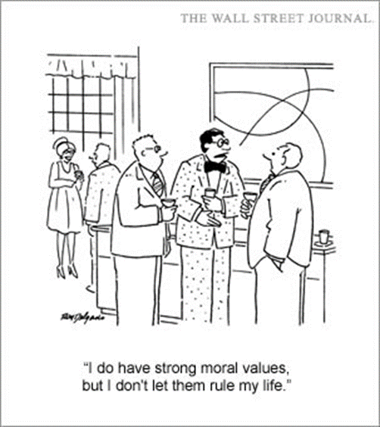
Source: henrykotula. 2017. Available from: https://henrykotula.com/2017/06/05/cartoon-i-do-have-strong-moral-values-but/

Construct an essay on dealing with emotions that come from grief, depression and trauma.

Use the following as a guideline:

- State FOUR benefits of being accountable for your actions. (4X1) (4)
When your personally accountable, you take ownership of what happens as a result of your choices and actions✓

You dont blame others or make excuses✓

Be honest, say sorry( take responsibility, if something has gone wrong)✓

If you take responsibility for your actions, learning and helps academic performances and achievements✓

- Assess the importance of respecting differences in the workplace. (2X4) (8)

​​ Any TWO of the below for FOUR marks EACH
(i.e. To be awarded the full FOUR marks for an ANALYSIS question:
candidates must give a statement, (✔) elaborate on the statement,
(✔) qualify the statement (✔) and give an outcome. (✔)

Respecting differences in the workplace:

Reduces stress ✓ - Stress reduction is crucial for the health and well-being of employees in the workplace✓ , forming good realtionships in the workplace✓ improving the culture and productivity of workers✓

Increases productivity✓ - A respectful working environment can offer more opportunities for your employees✓ to develop and improve skills✓ . Workers will feel valued and upskilled which improves workplace culture✓

When you show respect to your colleague, you value their opinions✓ and ask for their ideas on various issues and problems. ✓ This can lead to increased collaboration✓ and more creative solutions, benefiting the business/company as a whole✓

- Critically discuss factors that influence your attitude and behaviour as
teenagers. (2X4) (8)

​​ Any TWO of the below for FOUR marks EACH
(i.e. To be awarded the full FOUR marks for an ANALYSIS question:
candidates must give a statement, (✔) elaborate on the statement,
(✔) qualify the statement (✔) and give an outcome. (✔)

- Family✓ - Your actions are determined by your parents and caregivers when you are young✓ . Your choices are controlled by their values, attitude and morals✓ . Example, your family may choose a religion for your childhood✓

- Peer Pressure✓ - Peers and peer pressure become an important influence✓ , teenagers tend to spend more time with their friends and therefore tend to be more influenced by their friends✓ influencing your behavior both positively and negatively✓

- Community✓ - The community in which people live influence their personal lifestyle choices✓ because people's attitudes are often formed by those around them. ✓

- A positive influence✓ may include an exchange of ideas✓ where people learn from each other, become more open minded✓ and include their new views in their lifestyle choices✓ .

- Environment✓ - This refers to the conditions in which people live✓ . This includes fresh air, clean water, clean home and neighbourhood as a whole✓ . If people are living in poverty, personal lifestyle choices are affected because they have fewer opportunities available to them✓ .

- Culture✓ - Culture influences teenagers in their personal lifestyle choices because they have grown up within a specific cultural setting✓ . This includes certain beliefs, habits and expected behaviours in their upbringing✓ . Example: Certain cultures view rape as shameful and girls who are raped may not receive the support they need✓

- Religion✓ - Religious attitude influences the beliefs of their child.✓ Religion encourages people to think about the consequences of their actions✓ . Example: Studies have shown that teenagers who are involved in religious worship or youth groups are less likely to become involved in harmful behaviour✓ .

- Media✓ - The media such as newspapers, the internet, music, movies and social media✓ in general plays a huge role in shaping the decisions of teenagers. They are exposed to images of people's physical appearance and the lifestyle of others.✓ which could dictate how they view others. ✓

Question 4

Study the slide below and answer the question that follows:

Source: Koopman, G. 2022.
Goal Setting and Decision Making

You have noticed that a friend of yours has been struggling to cope with the demands of being a Grade 9 student. She often gets demerits because her homework is incomplete and she has not achieved any of the academic targets that she set for herself at the beginning of the year. You spend time thinking about how you can help her, and you decide to meet with her to discuss how she can get herself back on track.

Construct an essay on goal setting and decision making as it pertains to careers.

Use the following as a guideline:

- State FOUR benefits of setting SMART goals in regards to choosing
Grade 10 subjects. (4X1) (4)

- Gives you clarity✓
- Provides accountability✓
- Provides motivation✓
- Increases your chances of achieving your goals✓

- Assess the positive effect of choosing your subjects wisely for your future
career choices. (2X4) (8)

​​ Any TWO of the below for FOUR marks EACH
(i.e. To be awarded the full FOUR marks for an ANALYSIS question:
candidates must give a statement, (✔) elaborate on the statement,
(✔) qualify the statement (✔) and give an outcome. (✔)

This will enable you to focus✔ on the subjects that you have chosen and prevent you from changing subjects✓ Provides you with direction✓, allowing you to be better prepared for your career✓

A positive effect is understanding your strengths and weaknesses✔ , relating to what subjects your good at and what your not that good in✓
Gives the learner a sense of responsibility and accountability✓

- Critically discuss the importance of the decision-making process when it
comes to subject choice. (2X4) (8)

​​
Any TWO of the below for FOUR marks EACH
(i.e. To be awarded the full FOUR marks for an ANALYSIS question:
candidates must give a statement, (✔) elaborate on the statement,
(✔) qualify the statement (✔) and give an outcome. (✔)

​​o Speak to their LO teacher ✔ As they will be able to provide information about different options ✔
o Research what qualifications are needed for their potential career field ✔ this will let them see if they should leave school in Grade 9 of if they need to stay on and finish grade 12 ✔
o Speaking to people who have attended TVET colleges/ universities ✔ This may allow them to get a better understanding of what to expect at these different facilities ✔
o Can plan the direction they want to go✔ depending on the career field they are interested in ✔
o This could allow them to find an option that is more appealing to their interests and the way they learn✔ thus they could be more successful in a particular field✔
o To be able to challenge ‘normal’ ideas of studying and qualifications ✔ Thus allowing them agency over their own life✔
May provide them with option they did not know about ✔ This could open more doors for them✔

[20]

Question 5

Study the image and text below and answer the questions that follow:

Source: Unknown. 2022. Available from: www.teenactiv.co.za
NSC and NVC
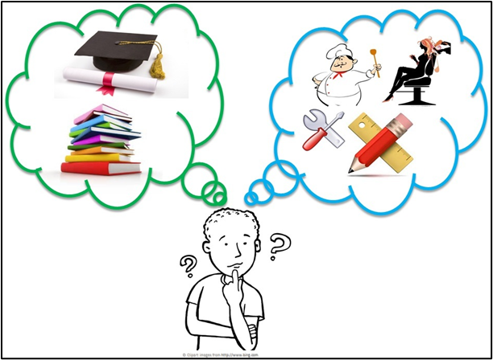

At the end of Grade 9, learners can decide to remain at school and complete their NSC or they can pursue an NVC. Both of these come with pros and cons.

Construct an essay on NSC and NVC.

Use the following as a guideline:

- State FOUR benefits of discussing your future subjects with one of your
subject teachers. (4X1) (4)
- Speak to their LO teacher As they will be able to provide information about different options ✔
- Subject teacher can help learners regarding what they must research relating to the qualifications that are needed for their potential career field ✔ this will let them see if they should leave school in Grade 9 of if they need to stay on and finish grade 12 ✔
- Speaking to people who have attended TVET colleges/ universities ✔ This may allow them to get a better understanding of what to expect at these different facilities ✔

- Assess the difference between NSC and NCV. (2X4) (8)

​​ Any TWO of the below for FOUR marks EACH
(i.e. To be awarded the full FOUR marks for an ANALYSIS question:
candidates must give a statement, (✔) elaborate on the statement,
(✔) qualify the statement (✔) and give an outcome. (✔)

National Senior Certificate✔✓ is a certificate that signals to learners and guardians that the individual has successfully completed his/her required years of schooling✔ whereas a National Certificate Vocational✔✓ is a qualification created to provide workplace-based skill sets in various career fields that are in demand in South Africa✔
- Critically discuss the positive outcomes of pursuing vocational training. (2X4) (8)
​​ Any TWO of the below for FOUR marks EACH
(i.e. To be awarded the full FOUR marks for an ANALYSIS question:
candidates must give a statement, (✔) elaborate on the statement,
(✔) qualify the statement (✔) and give an outcome. (✔)
- A vocational training teaches hands-on✔ , applied skills✔ which is more practical in nature✔ that makes learners more employable for practical work✔
- Vocational training graduates tend to go into the career they trained for✔ much quicker and easier ✔ This alleviates any indecision ✔ when needing to apply for job✔
- Vocational training is the action of teaching or learning practical skills or type of behaviour✔ which may benefit to learners who enjoy more practical learning ✔ which would improve their marks✔ and allow them to enter the job market quicker ✔
- Vocational training will provide you the opportunity to develop and receive recognition for skills✔ that can kickstart your specific career✔. Vocational training is designed to prepare you for entry-level employment in a career of your choice✔ allowing for a wider range of jobs to choose from✔
TOTAL SECTION C: 40
GRAND TOTAL: 70

