Jeppe High School for Boys

Grade: 11
Examination: Life Orientation

Date: 31 May 2022
Duration: 2½ Hours
Total Marks: 100
Examiner: B Riskowitz
QC Moderator: R Riskowitz
Number of Pages: 9

Instructions:

- Complete the front cover of your answer booklet.
- Answer all of the questions in the answer booklet provided.
- Number in the middle of the page.
- Rule off after each section.
- The following are not allowed in the examination room: school bags, cell phones,
smart watches, tablets, books, dictionaries, notes, sketches or paper.
Only the official examination material distributed by the invigilator is allowed.

SECTION A (COMPULSORY)
Answer ALL of the questions in this section.
QUESTION 1
1.1 Various options are provided as possible answers to the following questions.
Choose the most correct answer and write only the letter (A-D) next to the
question numbers (1.1.1 to 1.1.5) in the ANSWER BOOK, e.g. 1.1.6 B.

1.1.1 Which of the following is true about bursaries?

- Bursaries only need to be paid back if the students find a job with the
bursars.
- Students are expected to pay back the bursary’s interest while they study.
- School leavers who are financially needy are the only people who qualify.
- Companies that offer bursaries may expect students to work for their company.

1.1.2 Which of the following is a bursary provider?

- NBTs
- NQF
- NSFAS
- APS

1.1.3 How do democratic structures address the interests of civil society?

- They ensure that everyone is equal unless they cannot contribute financially.
- They encourage government to ignore different beliefs when making decisions.
- They allow everyone’s rights and responsibilities to be upheld, despite differences.
- They disregard the different cultural struggles by focusing on one goal.

1.1.4 Government mandates are:

- Meant to benefit the circumstances of a select few South Africans.
- There to improve the economy through uneven distribution of wealth.
- Supportive of violent criminal action and lawlessness within civil society.
- Created to support the fair running of the country to benefit all citizens.

1.1.5 A SMART goal should be measurable so that:

- People know that this goal is truly one of your main priorities in life.
- It helps you keep track of your progress and make adjustments.
- There is a deadline to create motivation and urgency to work.
- You have an unreasonable time limit to push yourself to succeed.
(5X1) (5)

1.2 Give ONE word/term for each of the following descriptions. Write only the
word/term next to the question numbers (1.2.1 to 1.2.3) in the ANSWER
BOOK.

1.2.1 The principle that no person is above the law. (1)

1.2.2 In sport, this is the action or practice of dishonestly determining the
outcome of a match before it is played. (1)

1.2.3 The fact of being responsible for what you do and able to give a
satisfactory reason for it, or the degree to which this happens. (1)

1.3 Answer the following questions by writing the answer next to the question
numbers (1.3.1 to 1.3.4) in the ANSWER BOOK. Write your answers in full
sentences.

1.3.1 Give TWO examples of steps that individuals could take when
setting goals for their future. (2X1) (2)

1.3.2 Explain why attaining tertiary education qualifications could ensure
employment for South African youth in the context of high youth
unemployment rates. (1X2) (2)

1.3.3 Why do some graduates not pay back their student loans? (2X1) (2)

1.3.4 Discuss the importance of why “sexting” can be considered
dangerous. (1X2) (2)

1.4 Study the image below and answer the questions that follow:

Source: Careers Portal. 2022. Available from: https://www.careersportal.co.za
Learnerships
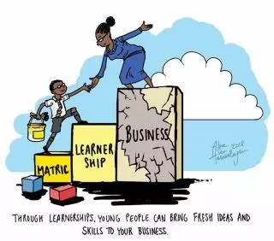

1.4.1 Explain why learnerships might be appealing to school leavers. (1X2) (2)

1.4.2 Recommend ONE possible strategy as to how school leavers could
make themselves stand out amongst other learnership applicants. (1X2) (2)
TOTAL SECTION A: 20

SECTION B (COMPULSORY)
Answer ALL of the questions in this section. Write your answers in full sentences.

QUESTION 2

Read the extract below and answer the questions that follow:

Source: UCT. 2022. Available from: https://www.news.uct.ac.za
Dealing with environmental factors that cause ill-health on a personal level

It was noon on Sunday, 18 April, when Professor Kelly Chibale, the warden of Smuts Hall men’s
residence, knew the historical building was in danger. The fire that had started in the Table
Mountain National Park quickly spread on the University of Cape Town’s (UCT) upper campus.
Community members, businesses, CBOs and NGOs went out in a frenzy to quell the raging fire. They forgot about their personal differences and worked as a unit to fight the fire.

Students at UCT were devasted as their study goals may be thwarted. Some were already
experiencing emotional health issues. They were worried about their assignments and what will
become of them if everything went up in flames.

Some were concerned about tertiary education funding, if the year was wasted. The majority did
not have the required registration fee. They were assisted by family members who could not further assist them. The personal and social challenges brought by the delays in the NSFAS funding makes things even worse.

2.1 Give the definition of the term ‘CBO’. (1X2) (2)

2.2 State TWO reasons why study goals would even be more important to UCT
students after the fire. (2X1) (2)

2.3 Explain ONE way in which CBOs could help the UCT students that lost their
accommodation and personal possessions. (1X2) (2)

2.4 Discuss TWO funding opportunities that those who lost everything in the fire
could consider in order to continue with their studies. (2X2) (4)

2.5 Assess how the fire could have caused emotional ill-health in UCT students. (2X2) (4)

2.6 Provide TWO strategies on what institutions such as universities can do to
prevent damage caused by natural disasters. In your answer, also indicate
how natural disasters, such as the UCT fire, could bring people together for
a common cause. (2X3) (6)
[20]

QUESTION 3

Read the extract below and answer the questions that follow:

Source: CNN.2022. Available from: https://edition.cnn.com
‘I will die for my community’: Taxi drivers fight back against looters

Taxi drivers guarding Vosloorus Mall, on Gauteng’s East Rand, opened fire on
looters with live ammunition. Members of the Katlehong People’s Taxi Association
have taken it upon themselves to protect malls around their communities.
According to members, a group of 500 taxi drivers have mobilised to defend malls
in the area.

A 13-year-old boy was killed during a skirmish between taxi drivers and a mob of
looters trying to burn down Vosloorus Mall. Vusi Dlamini was killed during the
crossfire. Two other dead people were found in the area.

Mineral resources minister Gwede Mantashe, visited his former ward and urged
people to protect their own infrastructure. As the situation remains tense, a large
police presence continues to monitor the area.

3.1 Give the definition of the term ‘public participation’. (1X2) (2)

3.2 State TWO reasons why public participation is an important factor in
upholding the democracy of South Africa. (2X1) (2)

3.3 Explain how the violent actions of the looters and the taxi drivers
may have harmed the community. (1X2) (2)

3.4 Discuss TWO alternative, non-violent methods of public participation which
could have been used by the taxi drivers in the above situation. (2X2) (4)

3.5 Assess TWO ways in which schools can assist in preventing future tragedies of
this kind. (2X2) (4)

3.6 Suggest TWO ways in which community leaders could hold the looters
accountable for their actions in a legal and responsible manner. In your
answer, also indicate how EACH suggestion could result in justice being
served. (2X3) (6)
[20]

TOTAL SECTION B: 40

SECTION C
Answer any TWO questions in this section.
Your responses must consist of paragraphs. Marks will only be allocated for responses written in full sentences.

QUESTION 4

Study the image below and answer the question that follows:

Source: Dotdash Media. 2022. Available from: https://www.verywellfamily.com.
Relationships
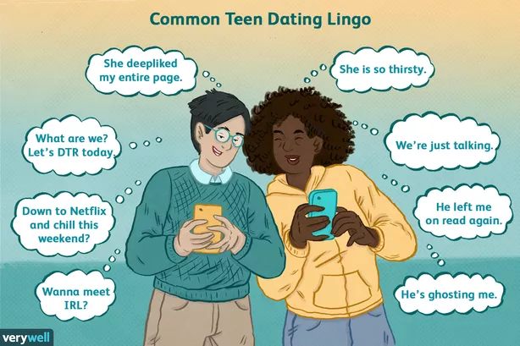

Construct paragraphs on Social Media and Relationships.

Use the following as a guideline:

- State FOUR ways in which teenagers may use social media to build their relationships. (4X1) (4)
- Analyse how social media can foster positive relationships that could
build a teenager’s emotional well-being. (2X4) (8)
- Critically discuss the impact that social media has had on teenage
relationships. (2X4) (8)
[20]

QUESTION 5

Read the extract below and answer the question that follows:

Source: Teenactiv. 2022 Available from: https://www.marca.com
Neymar used as example of bad sportsmanship by Kaizer Chiefs boss

Steve Komphela, coach of South African side Kaizer Chiefs, has singled out Neymar
as an example of how not to conduct oneself during games. The Barcelona forward
is known for entertaining fans with flashy tricks and soccer skills.

Komphela was unhappy with his players performing similar actions during their 3-0
Nedbank Cup win over Stellenbosch. ”You shouldn’t do that”, he said firmly. “Football is culture and tradition and that is what South Africans want from the game.”

Construct paragraphs on Good Sportsmanship.

Use the following as a guideline:

- State FOUR reasons why the coach may have viewed flashy soccer
tricks during a game as bad sportsmanship. (4X1) (4)
- Analyse the importance of professional sports players displaying good
behaviour in their national and international matches. (2X4) (8)
- Critically discuss ways in which the media could promote good
sportsmanship amongst soccer spectators. (2X4) (8)
[20]

QUESTION 6
Study the image below and answer the question that follows:

Source: MatricCollege. 2022. Available from: https://www.matric.co.za
CVs and job interviews

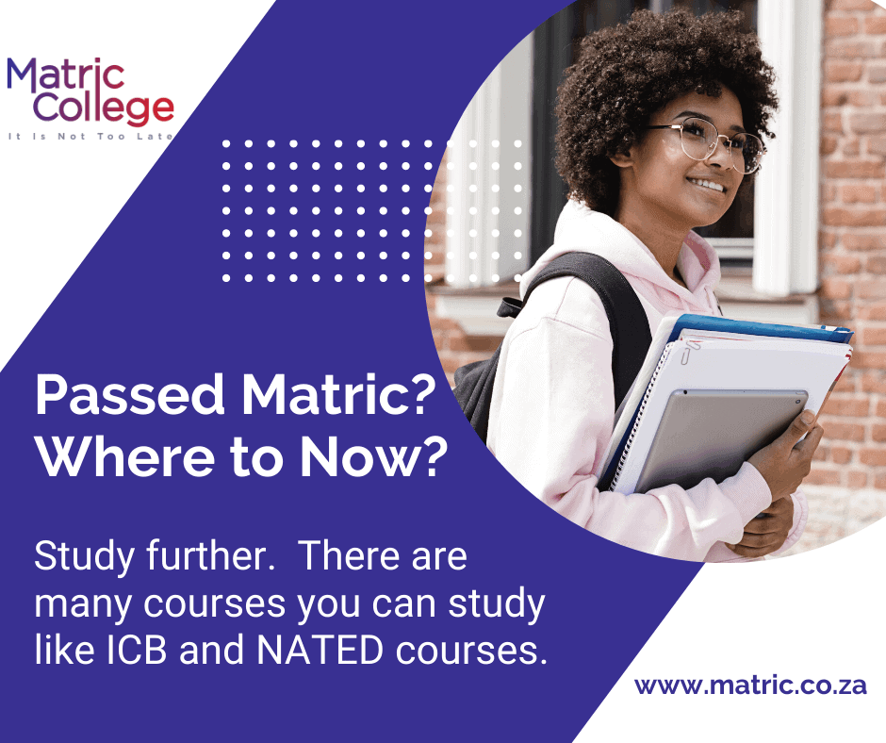

Construct paragraphs on CVs and Job Interviews.

Use the following as a guideline:

- State FOUR reasons why Grade 11s should start researching admission requirements for their chosen higher education course as early as
possible. (4X1) (4)
- Analyse why it is important for Grade 11s to maintain good marks if they
want to pursue tertiary education. (2X4) (8)
- Critically discuss additional options available to matriculants who do not
wish to study straight out of school. (2X4) (8)
[20]

TOTAL SECTION C: 40
GRAND TOTAL: 100

