Jeppe High School for Boys

Grade: 11
Examination: Life Orientation

Date: 27th September 2022
Duration: 2½ Hours
Total Marks: 100
Examiner: B Riskowitz
QC Moderator: R Riskowitz
Number of Pages: 8

Instructions:

- Complete the front cover of your answer booklet.
- Answer all of the questions in the answer booklet provided.
- Number in the middle of the page.
- Rule off after each section.
- The following are not allowed in the examination room: school bags, cell phones,
smart watches, tablets, books, dictionaries, notes, sketches or paper.
Only the official examination material distributed by the invigilator is allowed.

SECTION A (COMPULSORY)
Answer ALL of the questions in this section.
QUESTION 1
1.1 Various options are provided as possible answers to the following questions.
Choose the most correct answer and write only the letter (A-D) next to the
question numbers (1.1.1 to 1.1.5) in the ANSWER BOOK, e.g. 1.1.6 B.

1.1.1 Which of the following is true about bursaries:

- bursaries only need to be paid back if the bursar gives the student a job
- students are expected to pay back the interest on the bursary while they study
- school leavers who are financially needy are the only people who qualify
- companies that offer bursaries may expect students to work for them.

1.1.2 Which of the following is a bursary provider:

- NBT
- NQF
- NSFAS
- APS.

1.1.3 Which of the following is an example of abuse of power:

- a person setting clear boundaries that they expect their friends to respect
- using Eskom’s supply illegally
- a boyfriend asking his partner whether or not they are ready for intimacy
- Matric learners expecting Grade 8s to complete humiliating initiation tasks.

1.1.4 How do democratic structures address the interests of civil society?

- they ensure that everyone is equal unless they cannot contribute financially.
- they encourage the government to ignore different beliefs when making decisions.
- they allow everyone’s rights and responsibilities to be upheld, despite differences.
- they disregard the different cultural struggles/issues by focusing on one goal

1.1.5 An example of a violation of people’s environmental rights is:

- a toxic waste dumping ground situated near a primary school
- a partner being physically abused by their significant other
- school children not receiving textbooks at the start of the year
- a farmer spraying his crops with non-harmful pesticides.
(5X1) (5)

1.2 Give ONE word/term for each of the following descriptions. Write only the
word/term next to the question numbers (1.2.1 to 1.2.5) in the ANSWER
BOOK.

1.2.1 A segment of the workforce associated with a limited skill set or
minimal economic value for the work performed. (1)

1.2.2 Openness, accountability, and honesty. (1)

1.2.3 A system of society or government in which the father or eldest
male is head of the family and descent is reckoned through the
male line. (1)

1.3 Answer the following questions by writing the answer next to the question
numbers (1.3.1 to 1.3.3) in the ANSWER BOOK. Write your answers in full
sentences.

1.3.1 Explain how role models could help a high school learner make
positive lifestyle choices. (1X2) (2)

1.3.2 Why do Technical and Vocational Education and Training (TVET)
Colleges still hold importance in South Africa. (1X2) (2)

1.3.3 Discuss how Grade 11 learners could develop their project
management skills to assist them in their future careers. (1X2) (2)

1.4 Study the source below and answer the questions that follow:

Read This Before You Swipe Right on Tinder – Stranger danger is real

Alyssa didn’t meet this man at school or the mall—she met him on Tinder, the location-based dating app that lets you swipe right for “like” and left for “pass.”

[Adapted from https://www.teenvogue.com. Accessed:05 March 2022]

1.4.1 State TWO negative consequences of teenagers being exposed
to adults on apps like Tinder. (1X2) (2)

1.4.2 Define the term risky behaviour. (1X2) (2)

1.4.3 Suggest ONE way in which teenagers can keep themselves safe
when they meet people online. (1X2) (2)
TOTAL SECTION A: 20
SECTION B (COMPULSORY)
Answer ALL of the questions in this section. Write your answers in full sentences.
QUESTION 2

Read the extract below and answer the questions that follow:

Source: Teenactiv. 2021. Available from: www.teenactiv.co.za
‘Nobody Has Openings’: Mental Health Providers Struggle to Meet Demand

With anxiety and depression on the rise during the pandemic, it has been challenging for people to get the help that they need. After Jessica W was laid off from her job as an executive assistant in November, she began backsliding into the eating disorder that she thought she had overcome. “I started to not want to eat again,” Jessica, 33, said. “Those thoughts and behaviours — they’re just unbearable, and they drain you. It becomes a constant battle with yourself.” Jessica was also struggling with anxiety and depression, so she went online and started searching for mental health providers where she lived. One of the therapists she called wasn’t accepting new patients. Two of them told Jessica that they didn’t have the right skill sets to help her. Others simply didn’t respond.
Since the first CoronaVirus case was confirmed, the number of people in need of mental health services has surged. But many say that they are sitting on long waiting lists, making call after call only to be turned away, with affordable options tough to find. Providers, who have long been in short supply, are stretched thin.

2.1 Define the term psychological wellbeing. (1X2) (2)

2.2 State TWO factors that could contribute towards the growing
psychological ill-health in South Africa during the pandemic. (2X1) (2)

2.3 Explain why learners may struggle to prioritise psychological health. (1X2) (2)

2.4 How could psychological ill health negatively affect the academic
performance of high school learner’s. (2X2) (4)

2.5 Assess TWO ways in which high school learners could maintain their
psychological health while waiting to see a psychologist. (2X2) (4)

2.6 Advise psychologists on resources that they could provide for learners to
help them cope with mental strain whilst waiting for an appointment. In
EACH answer, also indicate how learners could help others with similar
issues. (2X3) (6)
[20]

QUESTION 3

Read the extract below and answer the questions that follow:
Plumbers, electricians and builders are in huge demand in South Africa

The demand for skilled artisans such as carpenters, toolmakers, fitters, joiners or mechanics has grown in South Africa, despite the impact of the Covid-19 pandemic. However, there is a scarcity of individuals trained and qualified to meet that demand. It is quite a cycle-resilient market, especially for those artisan-based businesses that serve homeowners or other small businesses. In other words, there will always be something broken in need of fixing or features that need an upgrade. There has also been a definite upward trend in the home improvement sector since the start of the Covid-19 pandemic. Learning a trade is one of the easiest entry points to self-employment and can provide a stable income and decent livelihood with the right support. It’s important to recognise that artisan-based businesses have different development needs to other businesses, a crucial one being access to market. Trade and vocational professions are also set to receive increased focus over the next five years, as part of a new programme by the Department of Higher Education and Training.

[Adapted from: https://businesstech.co.za Accessed on 03 September 2021]

3.1 Define the term skilled labour. (1X2) (2)

3.2 State TWO ways in which you can gain knowledge on skilled labour. (2X1) (2)

3.3 Explain how Grade 11 learners could acquire skills and competencies to
make studying a trade easier. (1X2) (2)

3.4 Discuss TWO ways in which high school learners could obtain job
shadowing opportunities in the vocational sphere? (2X2) (4)

3.5 Assess TWO ways in which technological advances, such as artificial
intelligence, positively affect skilled labourers and artisans in the
workplace. (2X2) (4)

3.6 Suggest strategies that the Department of Higher Education and Training
can put into place to create more interest in trade and vocational
professions. In EACH answer, also indicate how this could lead to more
learners pursuing trades and vocations. (2X3) (6)
[20]

TOTAL SECTION B: 40
SECTION C
Answer any TWO questions in this section.
Your responses must consist of paragraphs. Marks will only be allocated for responses written in full sentences.
QUESTION 4

Read the extract below and answer the question that follows:

Why Do Teens Consider Suicide?

Learning more about what might lead a teen to suicide may help prevent further tragedies.

The reasons behind a teen's suicide or attempted suicide can be complex. Although suicide is relatively rare among children, the rate of suicides and suicide attempts increases greatly during adolescence.

[Adapted from: https://kidshealth.org/en/parents/suicide.htmlAccessed on 23 June 2021]

Construct an essay on teenage suicide.

Use the following as a guideline:

- State FOUR risky situations that could lead teenagers to consider suicide. (4X1) (4)

- Analyse warning signs that parents and loved ones could look out for
which may indicate that a teenager is considering suicide. (2X4) (8)

- Critically discuss TWO possible strategies that teenagers could consider
instead of attempting suicide. (2X4) (8)
[20]

QUESTION 5

Study the image below and answer the question that follows:

Source: Johnson. 2022 Available from: https://medium.com/practical-growth/true-or-false-domestic-violence-ends-when-the-relationship-does-7ffb081ea812
Relationships
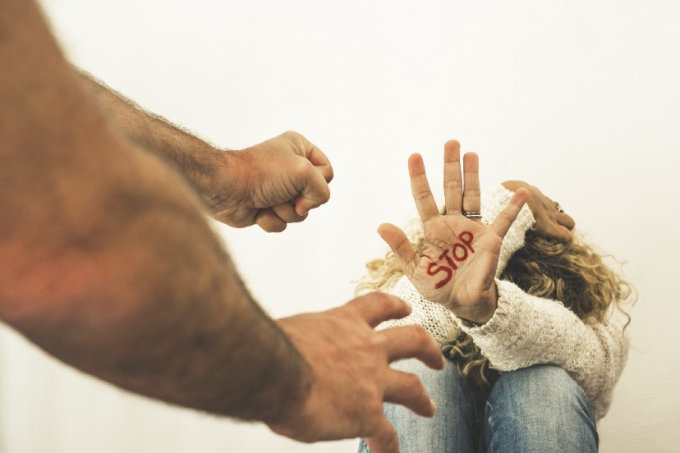

Construct an essay on violence in relationships.

Use the following as a guideline:

- State FOUR reasons why some relationships are more likely to be violent
than others. (4X1) (4)

- Analyse how experiencing violence within a relationship could lead to psychological trauma. (2X4) (8)

- Critically discuss the implications that relationships characterised by
ongoing violence could have on a survivor’s ability to trust others in future relationships. (2X4) (8)
[20]

QUESTION 6

Read the extract below and answer the question that follows:

Perceived Social Status Can Impact Your Job Search

While we hate to compare ourselves to others, we often are affected by our own perceptions of ourselves in comparison to others when it comes to work. The idea that our own socioeconomic status holds us back can even affect our ability to retain certain jobs or pursue a different job.

[Adapted from: https://www.businessnewsdaily.com Accessed on 03 September 2021]

Construct an essay on the impact of socio-economic status and career expectations.

Use the following as a guideline:

- State FOUR ways in which a higher socio-economic status can provide
more job opportunities. (4X1) (4)

- Analyse TWO ways in which employees could develop a more positive
perception of themselves in the working world. (2X4) (8)

- Critically discuss the importance of developing your self-knowledge to
better handle the stress in the world of work. (2X4) (8)
[20]

TOTAL SECTION C: 40
GRAND TOTAL: 100

