Jeppe High School for Boys

Subject: Life Orientation
Mid-Year Examination
Grade: 8

Date: 21 June 2018
Duration: 1 ½ Hours
Total Marks: 70
Examiner: J. De Lange
Moderators: B. Riskowitz
QC Moderator: C. Rattray
Number of Pages: 9
________________________________
Instructions:
- Complete the front cover of your answer booklet.
- Answer all questions in the answer booklet provided.
- Answer all questions in Sections A and B.
- Answer 2 questions from Section C.
- Write your teacher’s name on the front cover.
- Number in the middle of the page.
- Write neatly and legibly.
- Rule off after each section.
- No borrowing.
- The following are not allowed in the examination room: cell phones, school bags, ipods (or similar devices), books, dictionaries, notes, sketches or paper.
Only the official examination material distributed by the invigilator is allowed.

SECTION A: 15 Marks

QUESTION 1: Multiple Choice
Various options are provided as possible answers to the following questions. Choose the correct answer and write only the letter (A-D) next to the question numbers 1.1 – 1.10 in the answer book. E.g. 1.6 B

1.1 Drivers under the influence of marijuana have an increased risk of getting into a car accident because of:
A. slowed reaction time.
B. increased reaction time.
C. impaired judgement.
D. A and C.

1.2 A scarce skill is:
A. a skill that is difficult to obtain.
B. a skill that is more theoretical than practical.
C. a skill that is not in demand anymore.
D. a skill that not many people have.

1.3 Which of the following is not a short-term consequence of substance abuse?
A. Experiencing physical difficulties like headaches and nausea.
B. Forgetting academic deadlines.
C. Dropping out of school.
D. Absence from school due to being under the influence.

1.4 Someone who enjoys sketching and interior decorating could be described as: A. enterprising.
B. artistic.
C. conventional.
D. conservative.
1.5 If someone who is abusing drugs confides in a friend, the friend should react by:
A shouting at them.
B going straight to the police.
C showing compassion and care to help them.
D do nothing.
[5]

QUESTION 2: True or False
Indicate whether the following statements are TRUE or FALSE. Choose the answer and write only ‘true’ or ‘false’ next to the question number. Give a reason if the statement is FALSE.

2.1 A romantic relationship always includes a physical/sexual component.
2.2 Although we have a predominant learning style we may use more than one
style, depending on what we are learning.
2.3 A person can be only physically dependent on a drug.
2.4 Someone with an aural learning style might enjoy doing oral reports.
2.5 Self-esteem is fixed. You either have high self-esteem in all things or poor
self-esteem in all things.
[5]

Question 3: Definitions
Define the following terms:
3.1 acquaintance.
3.2 kinesthetic/kinaesthetic learning style.
3.3 social needs.
3.4 puberty.
3.5 polygamy.
[5]

SECTION A: 15 MARKS
SECTION B: 25 Marks

QUESTION 4: Scenario
Read the scenario below on relationships and answer the questions that follow:
One of your best friends, Max, cheated on his girlfriend a few times and claimed they were mistakes. She found out that he was cheating on her and she ended the relationship by sending a very bad text message to him and blocking him on all of her social media sites. Max felt terrible by the way his relationship ended and decided that he would never treat a girlfriend that way in the future.

He has recently been going out with a new girl and they look to be very happy. Everytime they are with each other they are always smiling, complimenting each other and they always want to go on more dates with one another. Now Max wants to ask her to be his girlfriend and because you have been in a healthy long-term relationship with your girlfriend, Max comes to you for relationship advice.
De Lange, 2018

4.1 Was the way in which Max’s ex-girlfriend ended their relationship
appropriate? Provide reasons to substantiates your answer. (2)
4.2 Name THREE (3) appropriate ways to initiate a relationship that are not
evident in Max’s new relationship. (3)
4.3 Provide Max with FOUR (4) appropriate behaviours that could prevent
problems in his new relationship. Give an example for each behaviour. (4X2)(8)
[13]

QUESTION 5: Case Study
Read the case study about Zweli below and answer the following questions:
Zweli’s school marks for Term One:
English 79
Afrikaans FAL 78
Mathematics 50
Natural Sciences 55
Social Sciences 80
Technology 55
Economic and Management Sciences 70
Creative Arts 80
Life Orientation 76
Extra-murals: Debating, library monitor, school band, Young Historians club, Poetry Club.
De Lange, 2018

5.1 In which TWO (2) school subjects is Zweli strongest? (2)
5.2 Into which career category do you think Zweli would fit best? (1)
5.3 Provide TWO (2) abilities recommended for the career category you chose
in question 5.3 that Zweli might have. (2)
5.4 Comment on the relationship between Zweli’s performance in her school
subjects and her interests as shown in her extra-mural activities. (2)
5.5 Considering the fact that Economic and Management Sciences has a written component, account for Zweli’s performance in this subject. (2)
5.6 Advise Zweli why he should not be thinking of choosing an investigative
career category. (3)
[12]
SECTION B: 25 MARKS
SECTION C: 30 Marks
Only answer TWO (2) of the THREE (3) following questions. Please read all instructions as these can affect your marks.

QUESTION 6
Analyse the cartoon below and answer the question that follows:
Source: JSCBlog. 2018. https://www.stanfield.com/blog/2015/10/6-tips-for-talking-about-sex-with-special-needs-teens/hear-to-heart-cartoon-2/
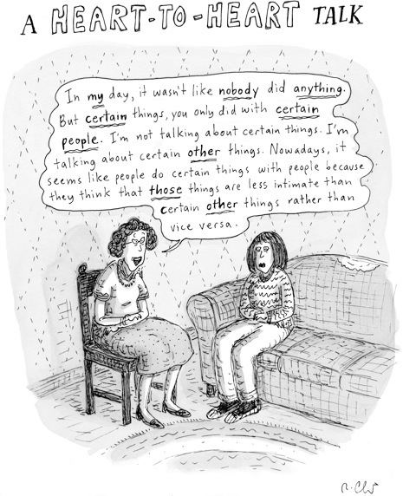

Construct an essay in which you critically evaluate why so many people struggle to speak about sexuality. Your answer must include the following:
6.1 A definition of sexuality.
6.2 A discussion TWO (2) reasons why so many people struggle to speak about
sexuality.
6.3 A recommendation and explanation TWO (2) ways to develop a healthy
understanding of sexuality.
6.4 A discussion of THREE (3) factors that impact and influence one’s sexuality.
[15]
AND/OR

QUESTION 7
Study the image below and answer the question that follows:
Source: Talimonov. 2011. https://www.cartoonstock.com/cartoonview.asp?catref=atan204
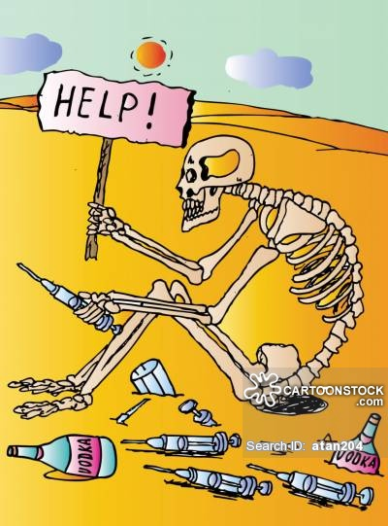
Compose an essay that illustrates your understanding of substance use/abuse. In your essay you should include the following:
7.1 A definition of substance abuse.
7.2 A discussion of TWO (2) social factors that contribute to substance abuse.
7.3 A discussion of TWO (2) negative consequence of substance abuse on an
individual who abuses them, in terms of each of the following:
a) emotional and behavioural consequences.
b) physical consequences. 7.4 A list TWO (2) South African organisations that would offer support and
care for substances abusers.
[15]
AND/OR

QUESTION 8
Analyse the image below and answer the question that follows:
Source: AliExpress. 2018. https://www.aliexpress.com/item/New-Handicrafts-Cat-Reflection-Tiger-5D-Diy-Diamond-Painting-Cross-Stitch-Animal-Diamond-embroidery-Mosaic-European/32789363122.html
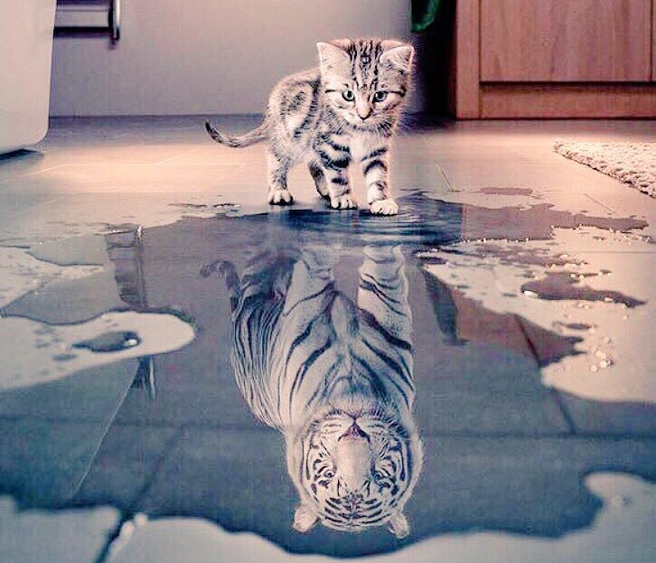
Construct an essay where you critically evaluate self-concept formation and self- motivation. In your essay you should include the following:
8.1 A definition and discussion on both self-concept formation and self-motivation.
8.2 A discussion of FIVE (5) ways in which you can develop a positive self-concept.
8.3 A discussion of provide and discuss THREE (3) factors that affect self-concept
formation and self-motivation. [15]

SECTION C: 30 MARKS

TOTAL: 70 MARKS

