MEMORANDUM
Grade: 8
Examination: Life Orientation
Date: 23rd November 2021

QUESTION 1
1.1.1 Which of the following would be an ideal way for a visual learner to learn?

- Drawing charts and diagrams.
- Singing rhymes and chants.
- Doing and enjoying touching.
- Reading their class notes.

1.1.2 What is meant by the term ‘refusal’?

- Saying yes.
- Saying no.
- Not saying no.
- Not making a choice.

1.1.3 Substance abuse refers to:

- Continued use of tobacco or alcohol and illegal drugs.
- Continued use of legal substances that make you feel good.
- Being dependant on something or someone that abuses you.
- Being dependant on a substance that makes you feel good.

1.1.4 Appropriate behaviour to stop and avoid substance abuse:

- Take up hobbies and sport to find friends that are users.
- Take only once a week to make you feel good about yourself.
- Do volunteer work, it makes you feel good about yourself.
- Play sports where substances are available to you.

1.1.5 Rehabilitation options include:

- Hospitals, non-governmental organisations and counselling.
- Non-governmental organisations, counselling and after care.
- Hospitals, counselling and places of substance abuse.
- Non-governmental organisations, counselling and the national drug line.

(5X1) (5)

1.2.1 The idea one has of one's abilities, appearance, and personality. (1)

Self-image / Self-concept

1.2.2 A ceremony or event marking an important stage in someone's life,
especially birth, the transition from childhood to adulthood, marriage,
and death. (1)

Rite of passage

1.2.3 A mark of disgrace associated with a particular circumstance,
quality, or person. (1)

Stigma

1.2.4 The collection and storage of rain, rather than allowing it to run off. (1)

Rain harvesting

1.2.5 A formal written request, typically one signed by many people,
appealing to authority in respect of a particular cause. (1)

Petition
TOTAL SECTION A: 10

SECTION B (COMPULSORY)
QUESTION 2

2.1 Give the definition of the term HIV/AIDS. (1X2) (2)

Any ONE of the below or any relevant answer for TWO marks
- AIDS (acquired immune deficiency syndrome) is the name used to describe a number of potentially life-threatening infections and illnesses that happen when your immune system has been severely damaged by the HIV virus.
- While AIDS cannot be transmitted from 1 person to another, the HIV virus can.

2.2 Identify TWO ways that Petunia may have become infected with HIV. (2X1) (2)

Any TWO of the below or any relevant answer for ONE mark each.

· Having unsafe sex ✓
- Through sharing injecting equipment when doing drugs ✓

2.3 Explain ONE of the ways that stigmatisation impacted the woman in the
extract emotionally. (1X2) (2)

Any ONE of the below or any relevant answer for TWO marks
(i.e. ONE mark for statement and ONE mark for qualifier / explanation)

· She felt humiliated and afraid ✓ and because of this did not take her medication ✓
She felt judged ✓ which probably made her feel guilt-ridden and depressed

2.4 Differentiate between HIV and AIDS. (2X2) (4)

HIV: refers to the viral infection which weakens the immune system ✓

AIDS: is known as the final stage of HIV infection where the immune system is too weak to fight off other infections ✓

2.5 Assess TWO ways that the woman can manage and fight her illness
to help her stay healthy for longer. (2X2) (4)

Any TWO of the below or any relevant answer for TWO marks each
(i.e. ONE mark for statement and ONE mark for qualifier / explanation)

· Petunia could start taking her ARVs daily ✓ in order to delay the onset of AIDS and keep her immune system strong ✓
· Petunia could start eating healthily ✓ and live a balanced and healthy lifestyle in order to keep her immune system strong ✓
Petunia could ask for support from people who care about her ✓ so that she could feel positive about her life and deal with her status emotionally ✓

2.6 Recommend TWO ways that Grade Eight learners can demonstrate
care for someone living with HIV/AIDS? In your answer, also indicate
how this will allow these learners living with HIV/AIDS make better decisions
in managing their illness. (2X3) (6)

Any TWO of the below or any relevant answer for THREE marks each
(i.e. ONE mark for statement and ONE mark for qualifier / explanation)

o Share with them that you do not judge them or look down on them for having HIV ✓ as stigma can really have a negative impact on medication compliance and emotional state ✓
o Do not use language that will make them feel judged ✓ as this will make them feel even worse about their condition ✓
o Encourage them to take their ARVs even if they experience side effects ✓ as medication non-compliance can be common in people who are HIV positive ✓
o Educate them and encourage them to lead a healthy lifestyle ✓ so that their immune systems will remain strong to fight off infections ✓
o Assist them in finding or accessing support networks ✓ in order to get expert help and support from people who know how to help ✓
o Do daily chores for them ✓ so that they will be able to rest more frequently. ✓
[20]

TOTAL SECTION B: 20

SECTION C
Answer any TWO questions in this section.

QUESTION 3

Construct an essay on COVID-19 and Gender-Based Violence.

Use the following as a guideline:

- State FOUR ways that victims of gender based violence experiences are
harmed. (4X1) (4)

- Analyse why South Africa still struggles with issues of gender-based
violence despite having human rights that oppose the problem. (2X4) (8)
- Critically discuss the importance of men and boys standing up against
gender-based violence. (2X4) (8)
[20]

QUESTION 4

Study the image below and answer the question that follows:

Source: Career Guide. 2021. “5 Misconceptions Of Career Counselling To Be Aware Of”. Available from: https://www.careerguide.com/career/career-counsellors/5-misconceptions-of-career-counselling-to-be-aware-of
Career Counseling

Construct an essay on Careers and Subject Choices.

Use the following as a guideline:

- State FOUR personal aspects that you should consider when deciding on a
career. (4X1) (4)
- Analyse how the relationship between the knowledge of various school
subjects and potential careers works. (2X4) (8)
- Critically discuss the importance of Grade 9s making the best possible
subject choices going into Grade 10. (2X4) (8)
[20]

QUESTION 5

Study the image below and answer the question that follows:

Source: Unknown. 2020. “Survey: Nurses fear going to work due to lack of protection from virus”. Available from: https://www.myamericannurse.com/survey-nurses-fear-going-to-work-due-to-lack-of-protection-from-virus/
Covid-19
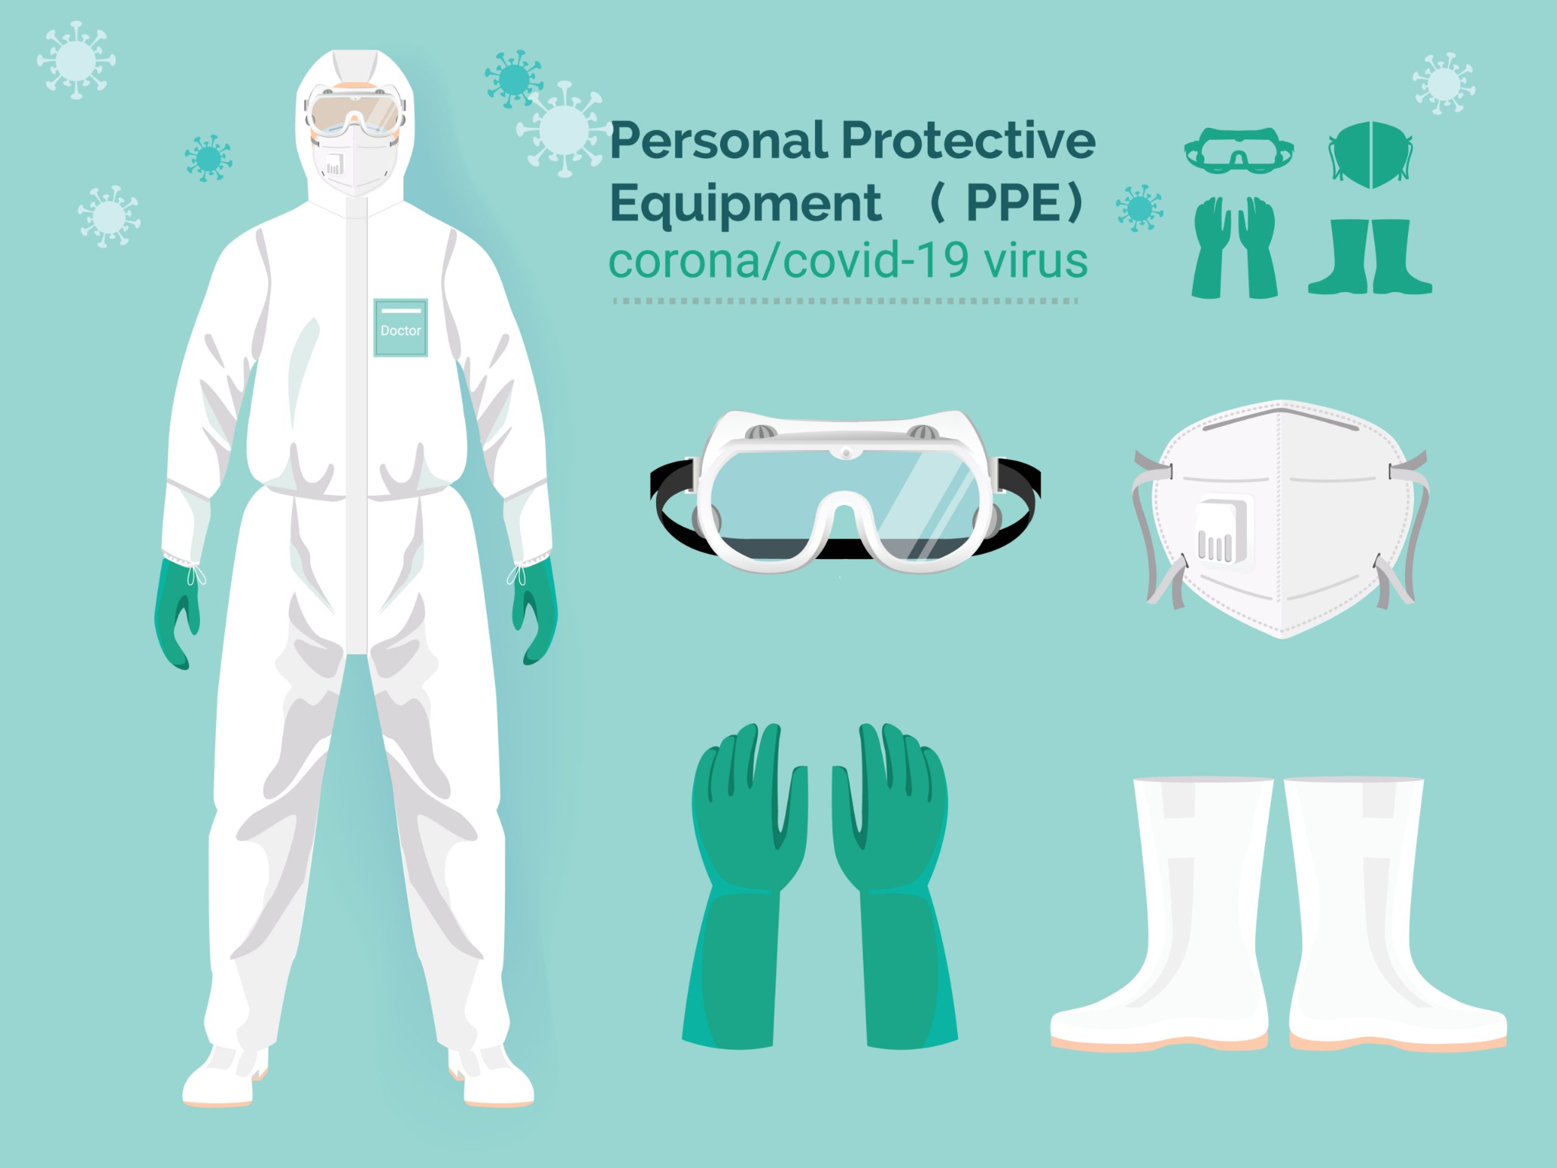

Construct an essay on Dealing with Covid-19.

Use the following as a guideline:

- State FOUR ways to protect yourself against Covid-19. (4X1) (4)
- Analyse how you can support someone who has lost someone from
Covid-19. (2X4) (8)
- Critically discuss the importance of making informed decisions about
your safety during the COVID-19 pandemic. (2X4) (8)
[20]

TOTAL SECTION C: 40
GRAND TOTAL: 70

