Jeppe High School for Boys

Subject: Life Orientation
Final Examination
Grade: 10

Date: 27th September 2018
Duration: 1 ½ Hours
Total Marks: 80
Examiner: B. Riskowitz
Moderators: T. Janse van Rensburg / L. Hallett
QC Moderator: G. Ruh
Number of Pages: 9
________________________________
Instructions:
- Complete the front cover of your answer booklet.
- Answer all questions in the answer booklet provided.
- Answer all questions in Sections A and B.
- Answer 2 questions from Section C.
- Write your teacher’s name on the front cover.
- Number in the middle of the page.
- Write neatly and legibly.
- Rule off after each section.
- No borrowing.
- The following are not allowed in the examination room: cell phones, school bags, ipods (or similar devices), books, dictionaries, notes, sketches or paper.
Only the official examination material distributed by the invigilator is allowed.

SECTION A: 20 Marks

QUESTION 1.1: Multiple Choice
Various options are provided as possible answers to the following questions. Choose the most correct answer and write only the letter (A-D) next to the question numbers 1.1 – 1.10 in the answer book. E.g. 1.6 B

1.1.1 Which ONE (1) of the following statements is false?
- Self-awareness means how much you know yourself.
- Self-esteem means how much you like and value yourself.
- Self-development means how much effort you put into project development.
- Self-confidence means how sure you are of yourself.

1.1.2 The following is an example of assertiveness:
- being too shy to speak to someone.
- able to communicate clearly and respectfully on what you believe to be right.
- forcing others to believe in what you believe in.
- not taking sides and to compromise.

1.1.3 Which of the following statements, regarding masculinity, is false?
- Masculinity refers to how muscular a person is.
- Masculinity refers to maleness.
- Masculinity refers to the behaves considered to be typical of men.
- Masculinity refers to how manly a person is.

1.1.4 The term used to describe the roles, beliefs and expectations that people typically
associated with being male or female is:
- sexual identity.
- sexual orientation.
- gender stereotypes.
- gender roles.
1.1.5 Flexibility is the ability:
- of the muscles to exert force during an activity.
- of the heart and lungs to supply oxygen to the muscles of the body.
- of the muscles to move for long periods of time and is an indicator of the muscles' ability to do the work.
- to move the muscles and joints through their full range of motion and is beneficial in injury prevention and relaxation.
[5]

QUESTION 1.2: Short Questions
Answer the following questions in full sentences, paying close attention to the mark allocations:
1.2.1 Explain the difference between social and environmental justice. (1X2) (2)
1.2.2 Provide TWO (2) typical interests, strengths and abilities generally
associated with the enterprising personality types. (2)
1.2.3 Provide an example of each of the following life domains: practical
becoming, leisure becoming, growth becoming. (3)
1.2.4 List TWO (2) forms of funding one could acquire for studying purposes. (2)
1.2.5 When does one have to pay PAYE tax? (1) [10]

QUESTION 1.3: Definitions
Define the following terms:
1.3.1 accessibility. (1)
1.3.2 campaign. (1)
1.3.3 fair discrimination. (1)
1.3.4 critical thinking skills. (1)
1.3.5 logical thinking skills. (1) [5]
SECTION A: 20 MARKS

SECTION B: 30 Marks
QUESTION 4: Cartoon Analysis
Study the cartoon below and answer the questions that follow:
Source: Granlund. 2016. http://euromaidanpress.com/2016/05/26/moscow-may-pre-emptively-boycott-rio-olympiad-inozemtsev-says/
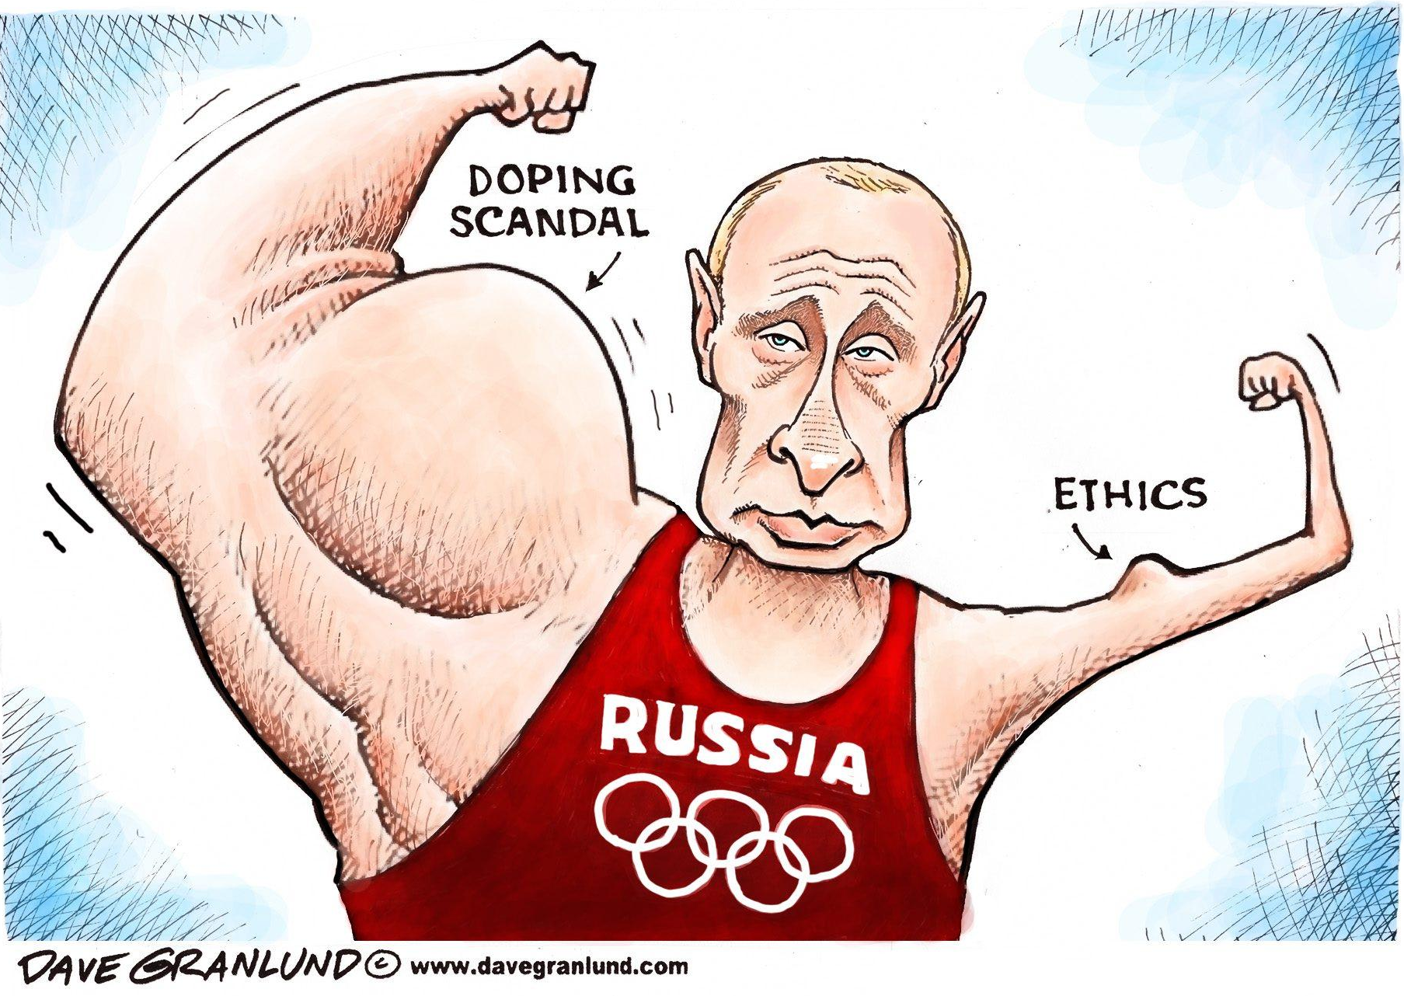

2.1 Define the term “drug taking” and show your understanding of the term by
means of a contemporary example from the world of sport. (1X2) (2)
2.2 Critically evaluate how doping scandals (as seen above) could tarnish
people’s perspectives of countries such as Russia. (2X2) (4)
2.3 Propose how society can change the attitudes and behaviours of athletes
partaking in unfair practices. (2X2) (4)
[10]

QUESTION 3: Scenario
Study the infographic below and answer the questions that follow:
Source: Murthy. 2016. https://business.linkedin.com/talent-solutions/blog/2014/01/top-10-job-titles-that-didnt-exist-5-years-ago-infographic

3.1 Determine the difference between a career and a career field. (1X2) (2)
3.2 Discuss why these industries may have experienced such large growth. (2X2) (4)
3.3 Evaluate the possible drawbacks in choosing a job that is very popular or
‘trendy’ at a point in time. (2X2) (4)
[10]

QUESTION 4: Case Study
Study the case study below and answer the questions that follow:
Source: Anonymous. 2016. https://www.today.com/health/my-boyfriend-left-me-when-i-got-pregnant-what-do-6C10935683
I'm 16 years old and have been with the same boy for more than two years. We got pregnant a few months ago, and everything was going great. But when I hit five months and summertime came, he took off, telling me he needed his freedom and space. He left me for his friends, so he could go drinking at bars whenever he wanted to.
I feel so lost and confused. I'm scared to death to have this baby all alone, and figure out how to care for this sweet little gift from God, while he gets to go off and party, feeling no remorse. I found out that a week after he left me he started dating another girl. My heart broke all over again. He has not contacted me in over a month and I don't know if I should contact him. The last time I tried, he was mean and hurtful in telling me he found someone else. I'm heartbroken. If you have any advice for me, I’d greatly appreciate it.

4.1 Define the term “value system” in light of the above case study. (1X2) (2)
4.2 Contrast the value system of the boy in the case study with the values he
should have adopted instead. (2X2) (4)
4.3 Suggest how the girl can cope with her current and soon-to-be life roles. (2X2) (4)
[10]

SECTION B: 30 MARKS

SECTION C: 30 Marks
Only answer TWO (2) of the THREE (3) following questions. Please read all instructions as these can affect your marks to some extent.

QUESTION 5
Study the excerpt below and answer the question that follows:
Source: Moosa. 2016. http://www.thedailyvox.co.za/race-transformation-agenda-gender-transformation-sports/
We need to speak about how badly sports women are paid
Women already must deal with misogyny and discrimination in all sectors of society solely by virtue, well, of them being women. And for women in sports, it’s further amplified.
Transformation is the buzzword of the moment since sports minister Fikile Mbalula announced that no sports tournament bids could be launched by sport associations until the transformation quota went up. This was no doubt an important and much-needed decision, but one conversation around transformation seems to be sidelined – that of the sexism that exists in sports.

Construct an essay in which you:
5.1 Briefly describe what “bias in sport” means and give an example of gender bias in
sport.
5.2 Critically discuss THREE (3) gender biases towards women in sport.
5.3 Suggest THREE (3) ways how society and the media can take up their
responsibilities and make positive changes to gender bias in sport.
[15]
AND/OR

QUESTION 6
Study the excerpt below and answer the question that follows:
Source: Anonymous. 2018. http://teenactiv.co.za
Lifelong learning ensures your continuous or ongoing self-development. This helps you to become a better person, with more knowledge and skills. As you develop and grow, you can achieve your potential. Your potential is your ability to do well in life. To help you develop yourself, you need to be able and willing to change, retrain, and be flexible.

Compose an essay that addresses the following:
6.1 Define the concept “flexibility” in the context of career searching and
explain why it is important.
6.2 Distinguish between the THREE (3) the three main forms of learning.
6.3 Critically discuss THREE (3) reasons why it is important to be a lifelong learner.
[15]
AND/OR

QUESTION 7
Study the image below and answer the question that follows:
Source: Muise. 2015. https://www.psychologytoday.com/us/blog/the-passion-paradox/201504/what-happens-when-your-partner-wants-do-it-you-dont
When Your Partner Wants To Do It But You Don't

Compose an essay in which you engage the following:
7.1 Briefly discuss the relationship between decisions and effects, using an example to
illustrate your answer.
7.2 Offer TWO (2) possible options for the woman above, other than to have sex.
7.3 Apply the FIVE (5) step problem-solving model to the situation above.
[15]

SECTION C: 30 MARKS
End of Paper
TOTAL: 80 MARKS

