Jeppe High School for Boys

Subject: Life Orientation
Final Examination
Grade: 11

Date: 27th September 2018
Duration: 1 ½ Hours
Total Marks: 80
Examiner: B. Riskowitz
Moderators: T. Janse van Rensburg / L. Hallett
QC Moderator: G. Ruh
Number of Pages: 10
________________________________
Instructions:
- Complete the front cover of your answer booklet.
- Answer all questions in the answer booklet provided.
- Answer all questions in Sections A and B.
- Answer 2 questions from Section C.
- Write your teacher’s name on the front cover.
- Number in the middle of the page.
- Write neatly and legibly.
- Rule off after each section.
- No borrowing.
- The following are not allowed in the examination room: cell phones, school bags, ipods (or similar devices), books, dictionaries, notes, sketches or paper.
Only the official examination material distributed by the invigilator is allowed.

SECTION A: 20 Marks

QUESTION 1.1: Multiple Choice
Various options are provided as possible answers to the following questions. Choose the most correct answer and write only the letter (A-D) next to the question numbers 1.1 – 1.10 in the answer book. E.g. 1.6 B

1.1.1 The following is not an example of community service:
- visiting an old-age home.
- cleaning up litter in your neighbourhood.
- ensuring that your needs are attended to.
- putting money into building up local infrastructure.

1.1.2 The term “desertification” means:
- the process whereby areas of land turn to desert.
- the norm of fathers leaving their families and not taking responsibility.
- the culinary term for producing confectionaries.
- when a learner loses their Matric certificate due to cheating.

1.1.3 The following is not a resource we lack as South Africans:
- land.
- water.
- fishing stocks.
- vitamin D.

1.1.4 Artificial food additives are chemicals known to cause:
- weight loss.
- endurance.
- attention-deficit disorder.
- healthy gums.

1.1.5 Which one of the following is not a time management skill?
- Procrastination.
- Goal setting.
- Prioritising.
- Decision-making.
[5]

QUESTION 1.2: Short Questions
Answer the following questions in full sentences, paying close attention to the mark allocations:
1.2.1 Explain the difference between adaptation and mitigation. (1X2) (2)
1.2.2 Name THREE (3) important study skills one can use to achieve better
results. (3X1) (3)
1.2.3 Differentiate between sportsmanship and gamesmanship. (1X2) (2)
1.2.4 Explain the purpose of the Government Gazette. (1)
1.2.5 What is the difference between a postgraduate and an undergraduate
degree? (2) [10]

QUESTION 1.3: Definitions
Define the following terms:
1.3.1 efficiency. (1)
1.3.2 advocacy. (1)
1.3.3 abstentions. (1)
1.3.4 vulnerable. (1)
1.3.5 civil society. (1) [5]
SECTION A: 20 MARKS

SECTION B: 30 Marks
QUESTION 4: Case Study
Read the case study below and answer the questions that follow:
Source: Unknown. 2018. http://sheconquerssa.co.za/sexual-gender-based-violence/
Adolescent girls and young women experience sexual and gender-based violence at a rate that is unacceptable. One-third of young girls in South Africa experience abuse. Rape also affects a huge number of women and girls, with over 48 000 rapes reported to the South African National Police Service (SAPS) in 2013 – and many more going unreported.

These forms of violence are often connected to poverty, as well as to society’s expectations about male and female roles. This is why it’s essential to support and empower girls and young women to find or create jobs for themselves – being independent gives them more power and opportunity. On a larger scale, we need to start changing society’s views about women having less power and less of a voice than men do.

2.1 Define the term “gender-based violence” and show your understanding of
the term by means of an example. (1X2) (2)
2.2 Critically analyse why males are not as involved in campaigns against
gender-based violence as women are? (2X2) (4)
2.3 Evaluate and discuss why so many rapes go unreported. (2X2) (4)
[10]

QUESTION 3: Image Analysis
Study the images below and answer the questions that follow:
Source: MBN. 2018. https://marketbusinessnews.com/financial-glossary/unskilled-labor/unskilled-labor-2/
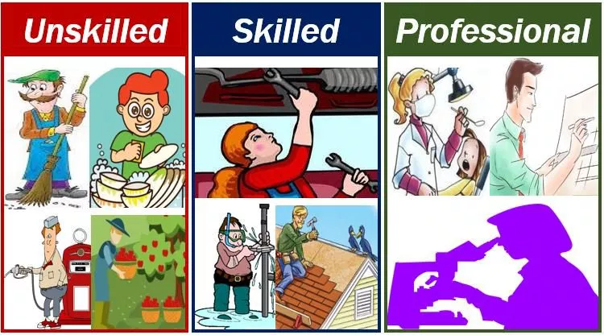

3.1 Define the term ‘“job market’’ and briefly describe the socio-economic factors
that may affect the job you end up pursuing. (1X2) (2)
3.2 Differentiate between skilled and unskilled labour. (2X2) (4)
3.3 Critically discuss TWO (2) negative consequences of being an unskilled
worker. (2X2) (4)
[10]

QUESTION 4: Case Study
Study the case study below and answer the questions that follow:
Source: Murano. 2015. https://www.oddee.com/item_99258.aspx
The 14 year old Chilean Girl who asked the President to let her die
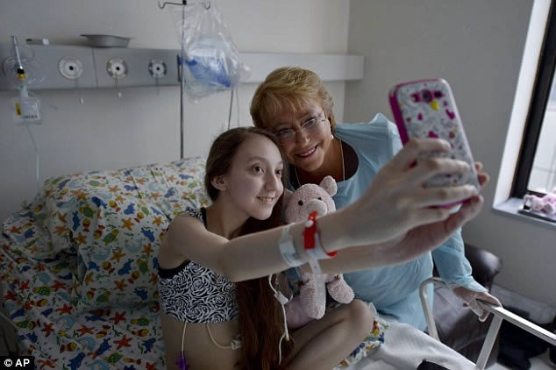
A 14-year-old Chilean girl suffering from terminal cystic fibrosis is asking her country's president for permission to end her life.
Valentina Maureira, who was diagnosed with cystic fibrosis as a baby, recently published an emotional self-shot video on her Facebook page pleading for a meeting with Chilean President Michelle Bachelet.
“My name is Valentina Maureira, I am fourteen and I suffer from cystic fibrosis,” the teenager says in the video, which she filmed with a cellphone in her hospital room. “I need to speak urgently with the president because I am tired of living with this disease, and she can authorize an injection that will allow me to sleep forever.” The video, posted on February 2015, has gone viral on YouTube.
A Chilean government spokesman said that the nation's laws, which prevent assisted suicide, also prevent the president from granting Valentina's request. But the teenager's desperate plea has moved the South American nation of 20 million. #ValentinaMoureira became the top trending topic on Chilean Twitter. The girl's video has also sparked a broader conversation about whether euthanasia should be legalized in the largely Catholic nation.
President Bachelet, who is also a pediatrician, eventually made an hour long visit to see Valentina.
Cystic fibrosis, a genetic disease with no cure, severely debilitates patients by clogging their lungs and organs with thick layers of mucus. Valentina, who weighs 77 pounds, relies on breathing machines and is fed through a tube. Her plea for euthanasia came after the death of another cystic fibrosis patient at her hospital a month ago.

4.1 Define the term “euthanasia” and show your understanding by means of
an example. (1X2) (2)
4.2 Critically analyse how a person’s religious belief system can help them to
respect the opinion of others with regard to the issue of euthanasia? (2X2) (4)
4.3 Strategise how you could respectfully and humbly deal with someone who
aims to persuade you to take the same moral stance as them? (2X2) (4)
[10]

SECTION B: 30 MARKS

SECTION C: 30 Marks
Only answer TWO (2) of the THREE (3) following questions. Please read all instructions as these can affect your marks to some extent.

QUESTION 5
Study the image below and answer the question that follows:
Source: Badorina. 2018. https://www.123rf.com/photo_50549801_stock-vector-human-thin-fat-nutrition-food-new-illustration.html

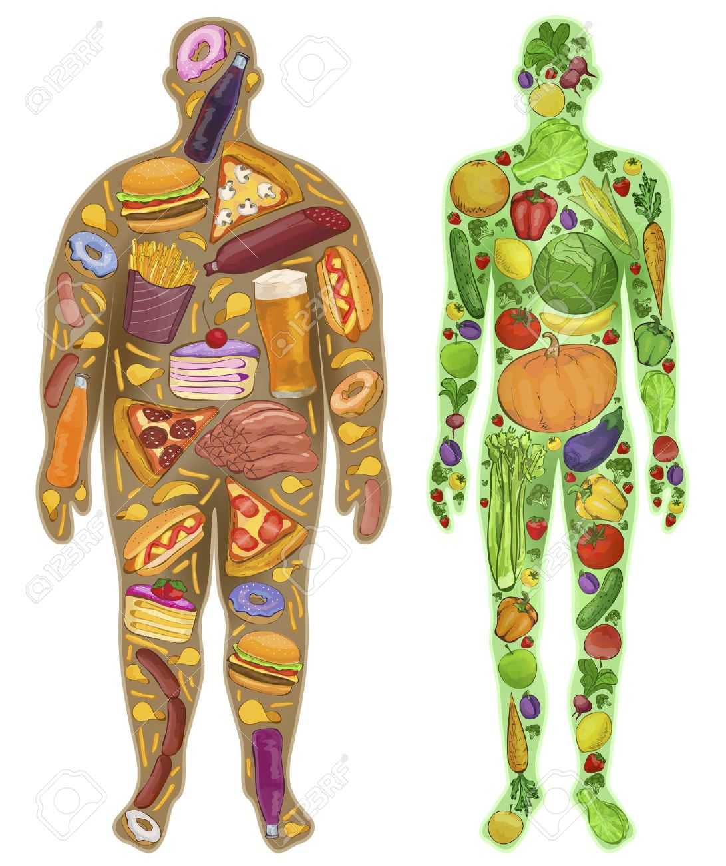

Construct an essay in which you:
5.1 Briefly define what nutrition is and mention any TWO (2) nutrients that your body
needs to stay healthy.
5.2 Critically discuss why it is difficult for people to follow a nutritious, balanced diet?
5.3 Evaluate the impact of nutrition on your health.
[15]
AND/OR
QUESTION 6
Study the excerpt below and answer the question that follows:
Source: Shaikh. 2018. Adapted from: https://dailytimes.com.pk/276991/the-least-recognized-human-rights-abuse/
Over 10,000 cases of GBV were reported in Pakistan in 2014. Acts of violence committed against women include, sexual violence, intimate partner or spousal abuse (domestic violence), sexual harassment, harmful traditional practices (forced marriage, vanni, karo kari), and other biased practices based on gender.

Compose an essay that addresses the following:
6.1 Define the term “”human rights violations”” and briefly explain under which
circumstances it is normally bound to happen.
6.2 Critically discuss how the cultural practices in the above excerpt contrast with a
victim’s basic human rights.
6.3 Propose THREE (3) ways in which women and girls who are subjected to these
practices, can be empowered to protect their rights.
[15]
AND/OR

QUESTION 7
Study the cartoon below and answer the question that follows:
Source: Fry. 2018. https://i.pinimg.com/originals/4e/13/6c/4e136c33d65ad085fa746d7fde21b5a3.jpg
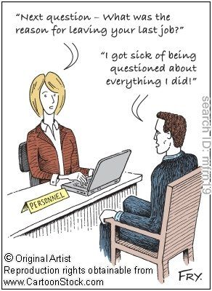

Compose an essay in which you engage the following:
7.1 Define the term “interview” and explain its purpose.
7.2 Critically analyse the interview skills that the interviewee displays in the cartoon.
7.3 Suggest THREE (3) more appropriate ways in which the interviewee in the cartoon
above could conduct himself through the rest of the interview.
[15]

SECTION C: 30 MARKS
End of Paper
TOTAL: 80 MARKS

