Jeppe High School for Boys

Grade: 10
Examination: Life Orientation

Date: 12th November 2021
Duration: 2 Hours
Total Marks: 100
Examiner: B. Riskowitz and J. de Lange
QC Moderator: R. Riskowitz
Number of Pages: 9

Instructions:

- Complete the front cover of your answer booklet.
- Answer all of the questions in the answer booklet provided.
- Number in the middle of the page.
- Rule off after each section.
- The following are not allowed in the examination room: school bags, cell phones,
smart watches, tablets, books, dictionaries, notes, sketches or paper.
Only the official examination material distributed by the invigilator is allowed.

SECTION A (COMPULSORY)
Answer ALL of the questions in this section.
QUESTION 1
1.1 Various options are provided as possible answers to the following questions.
Choose the most correct answer and write only the letter (A-D) next to the
question numbers (1.1.1 to 1.1.5) in the ANSWER BOOK, e.g. 1.1.6 B.

1.1.1 Abuse and destructive attitudes based on opinions and inexperience
can be referred to as:

- Xenophobia
- Discrimination
- Stigmatisation
- Situational Bias

1.1.2 Which of the following is NOT an example of social justice?

- Disallowing someone from voting because of their sex, race or religion.
- Promoting free healthcare for all South Africans, despite their income.
- Aiding refugees by providing them with safe lodging, food and clothing.
- Stopping someone in a wheelchair from playing a sport for safety reasons.

1.1.3 Violence can have a negative impact on communities in the following
way:

- It allows people to stay informed through violent protests.
- It creates a culture of aggression within the community.
- People are encouraged to solve conflict peacefully.
- It uplifts those who have previously been oppressed.

1.1.4 Unhealthy power relations can be defined as:

- To have control over another person.
- Teachers could use their authority to punish learners.
- When one person leads the people around them.
- Sharing the power between two people in a relationship.

1.1.5 Which of the following is true about gender differences in participation
in physical activities?

- Women are less likely to be physically active in comparison to males.
- Authorities assign physical tasks to women to avoid charges of sexism.
- Women who play more physical games are seen as feminine.
- Women involved in physical jobs earn higher salaries than males.
(5X1) (5)

1.2 Give ONE word/term for each of the following descriptions. Write only the
word/term next to the question numbers (1.2.1 to 1.2.3) in the ANSWER
BOOK.

1.2.1 The action or practice of dishonestly determining the outcome of a
match before it is played. (1)

1.2.2 The different aspects and experiences of life that we all consider
as we age and grow. (1)

1.2.3 Research conducted to observe and understand the effects of the
introduction of a new policy or strategy. (1)

1.3 Answer the following questions by writing the answer next to the question
numbers (1.3.1 to 1.3.4) in the ANSWER BOOK. Write your answers in
full sentences.

1.3.1 Give TWO examples of community service that the youth can be
involved with. (2X1) (2)

1.3.2 Explain why there is such a high degree of mismanagement in our
municipalities. (1X2) (2)

1.3.3 Why do some men feel the need to exert power over women? (2X1) (2)

1.3.4 Discuss the importance of continuous self-development especially
during times of difficulty such as the pandemic. (1X2) (2)

1.4 Read the extract below and answer the questions that follow:

Source: HRW. 2021. “Covid-19 and Children’s Rights”. Available from: https://www.hrw.org/
Covid-19 and Children’s Rights

Children who contract COVID-19 appear to have less severe symptoms and lower mortality rates than other age groups. But in countless other ways, the COVID-19 crisis is having a devastating effect on children; with a potentially far-reaching and long-term negative impact. More than 1.5 billion students are out of school, and widespread job and income loss as well as economic insecurity are likely to increase rates of child labour, sexual exploitation, teenage pregnancy, and child marriage.

Stresses on families, particularly those living under quarantine, lockdown and other restrictions on freedom of movement, may increase the incidence of violence in the home. As the global death toll from COVID-19 increases, large numbers of children will be orphaned and vulnerable to exploitation and abuse.

This report outlines key human right risks to children related to the COVID-19 crisis, and the steps that governments should take to protect children’s rights in the pandemic, mitigate its devastating effects, and benefit children after the crisis is over.

1.4.1 Explain why gender-based violence, due to unequal power relations,
increased because of the pandemic. (1X2) (2)

1.4.2 Recommend ONE way that all parents and children can stay
informed about the convention of the rights of a child. (1X2) (2)
TOTAL SECTION A: 20

SECTION B (COMPULSORY)
Answer ALL of the questions in this section. Write your answers in full sentences.

QUESTION 2

Read the extract below and answer the questions that follow:

Source:Teenactiv, 2021. Available from: [https://www.iol.co.za/news
These are the 2021 critical job skills SA most needs

Minister of Home Affairs, Dr Aaron Motsoaledi, recently published the 2021 Critical Skills List. More than 100 skilled occupations needing skilled professionals are named. Acute shortages have been identified.

Despite the high unemployment rate, there are still employers searching for workers in some fields in which there are not enough applicants. To enhance your chances and number of opportunities, it would be worth considering gearing your career choice to one of these. By doing so, you can take advantage of shortages in available candidates and a relative lack in competition.

2.1 Give the definition of the term “scarce skills”. (1X2) (2)

2.2 State TWO reasons why learners need to be aware of scarce skills. (2X1) (2)

2.3 Explain ONE benefit of choosing a career that is on a critical skills list. (1X2) (2)

2.4 Discuss TWO ways in which the youth can fund their own studies. (2X2) (4)

2.5 Analyse TWO ways in which the global pandemic could have had an
influence on the scarce skills list in South Africa. (2X2) (4)

2.6 Provide TWO strategies that school learners could put into place to ensure
that they are ready for future job trends. In your answer, also indicate how
EACH strategy could lead to more employment opportunities in their future. (2X3) (6)

[20]

QUESTION 3

Study the image below and answer the questions that follow:

Source:Teenactive, 2021. Available from:[https://www.flickr.com/photos/royblumenthal
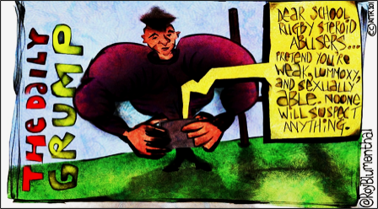
Dear school rugby steroid abusers… pretend you’re weak, lummoxy [a clumsy, stupid person] and sexually able. No one will suspect anything.

3.1 Give the definition of the term “substance abuse”. (1X2) (2)

3.2 State TWO reasons why athletes may take part in doping. (2X1) (2)

3.3 Explain ONE negative effect of taking drugs in sports. (1X2) (2)

3.4 Discuss TWO examples of bias in sports coverage. (2X2) (4)

3.5 Assess TWO ways in which different sport bodies could discourage
doping in their sport. (2X2) (4)

3.6 Provide TWO strategies that your school can adopt to prevent steroid use within
school sports. In your answer indicate how these strategies can be
implemented most effectively in a school context. (2X3) (6)

[20]
TOTAL SECTION B: 40
SECTION C
Answer any TWO questions in this section.
Your responses must consist of paragraphs. Marks will only be allocated for responses written in full sentences.
QUESTION 4

Study the image below and answer the question that follows:

Source: TransPerfect. 2021. Available from: https://www.transperfect.com

Construct an essay on gender stereotyping in the workplace.

Use the following as a guideline:

- State FOUR ways in which stereotypes could negatively affect upward
progression of females in the workplace. (4X1) (4)
- Analyse why poor treatment of individuals in the workplace could lead to
psychological issues in these individuals. (2X4) (8)
- Critically discuss the impact that businesses could have when challenging
stereotyping of individuals based on their gender in the workplace. (2X4) (8)
[20]

QUESTION 5

Read the extract below and answer the question that follows:

Source: U.S. Chamber of Commerce. 2021. “Startup”. Available from: https://www.uschamber.com/co/start/startup
Post-Pandemic Businesses
The impact of COVID-19, particularly on the business world, could not have been predicted, but has been an incredible learning experience—especially for aspiring entrepreneurs. Entrepreneurs are innovative, creative and risk-taking by definition so establishing a business in or immediately after a pandemic does not frighten many away.

E-commerce has always occupied an important space in the marketplace and the pandemic showed us both the resilience of businesses selling online and the demand of community members looking to support local and small businesses. Online stores are the best avenue for aspiring retailers of homemade products like hand-knitted gloves, infused olive oil and more. Crafters and artisans have a unique opportunity to build a following on social media like Instagram and TikTok and turn their passion and skills into a thriving business on sites like Etsy.

Construct an essay on the life roles of new teenage entrepreneurs.

Use the following as a guideline:

- State FOUR extra responsibilities that teenage entrepreneurs could face due
to the pandemic. (4X1) (4)
- Analyse how the pandemic could put further pressure on a teenage
entrepreneur’s life role as a family member. (2X4) (8)
- Critically discuss the importance of how an entrepreneur finding balance
in their life role as a teenage entrepreneur with their life role as an
academic in this changing environment. (2X4) (8)
[20]

QUESTION 6

Study the image below and answer the question that follows:

Source: Unknown. 2021. Available from: [https://main-bet.com
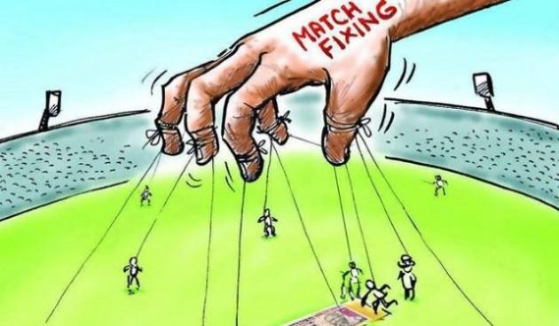

Construct an essay on maladministration in sports.

Use the following as a guideline:

- State FOUR ways that sports maladministration may pose challenges to sports
post pandemic in South Africa. (4X1) (4)
- Analyse why professional players might get involved in match fixing. (2X4) (8)
- Critically discuss the importance of society's role in influencing change in
the attitudes of professional players considering match fixing in sports. (2X4) (8)
[20]

TOTAL SECTION C: 40
GRAND TOTAL: 100

